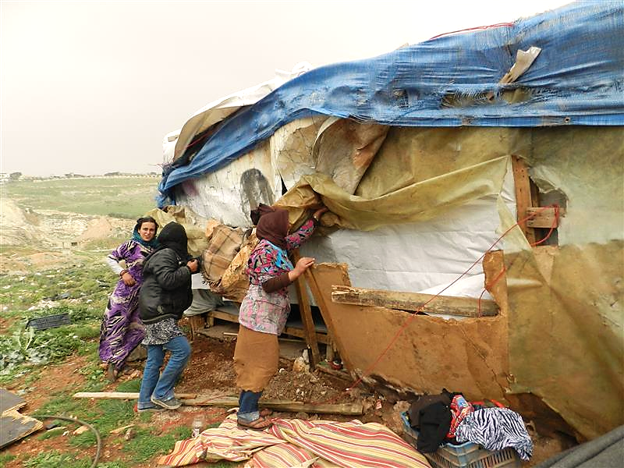



Syria Crisis I Aleppo Governorate

**Key Informants Assessment Report**

**July 2014**

# Summary

Since October 2013, extensive fighting and aerial shelling have increasingly affected Aleppo Governorate and its capital Aleppo City and led to massive population displacement, creating new internally displaced persons (IDPs) and forcing existing IDPs to re-displacement. As of early July 2014, significant population displacement was ongoing in Aleppo Governorate following surging conflict, notably around Aleppo City that came close to being besieged. In a context where reliable information is scare and in support of contingency planning by the humanitarian community targeting aid for new IDPs, **REACH conducted a key informant assessment between April and May 2014 focusing on the needs of conflict-affected populations throughout Aleppo Governorate**.

REACH conducted this assessment in consultation with the Inter-sector Coordination Group and the Assessment Working Group for Northern Syria, as well as local humanitarian partners and NGO coordination platforms. Funded by the Office of U.S. Foreign Disaster Assistance (OFDA), the assessment aimed to address an information gap regarding the humanitarian and displacement situation in Aleppo Governorate. The methodology applied for this assessment is presented at the beginning of the report, including the ranking approach used to evaluate the reliability of the collected data. Population figures and findings presented in this report are only valid as of mid-May 2014.

This report provides, first, a displacement section encompassing a **IDPs count per assessed sub-district** of Aleppo Governorate and an **overview of displacement patterns** as of May 2014.Second, focusing on the **humanitarian situation in terms of food, water and health** in Aleppo Governorate, the report provides an **estimation of the severities of needs by sector at sub-district level**, and argues that across these three sectors deficiencies are important in various sub-districts of Aleppo Governorate.

**Displacement**

* **More than 629,000 people were estimated to be displaced across the 26 assessed sub-districts.** The sub-district recording the highest number of IDPs was found to be Menbij (137,000), which was also estimated to have the highest number of IDPs amongst all sub-districts assessed by the Syria Integrated Needs Analysis (SINA) in November 2013. Across 22 sub-districts assessed by both assessments for which data is reliable, the SINA recorded over 352,000 IDPs and the Aleppo Governorate assessment recorded over 448,000 IDPs, showing an increase by an estimated 96,000 IDPs[1].
* Four areas have been determined to beprimary **areas of origin for IDPs** within Aleppo Governorate**: Aleppo City,** as well as the **Rural Jebel Saman, As Safira and Al Bab sub-districts.** Apart from IDPs from rural Jebel Saman, the majority of IDPs from other areas are displaced toward Menbij sub-district, followed by sub-districts in Jarablus and A’zaz districts, near the Turkish border.
* **Displacement patterns are regulated by several factors**. Increased **conflict** is the main “push” factor triggering internal displacement from areas of origin while perceived **safety** in areas of resettlement is a major “pull” factor. IDPs are also trying to resettle in areas where **better living conditions** are available. However, such additional factors as IDP’s **personal networks**, IDP’s **available resources**, IDP’s **educational background and skillset**, the **distance from the area of origin** also come into play in determining IDP’s areas of resettlement.

**Food**

* All assessed sub-districts in Aleppo Governorate are facing **extensive food shortages.** Highest food insecurity severity levels were identified in Dayr Hafir and Rasm Haram El-Imam sub-districts in Al Bab district, Khanaser sub-district in As Safira district and Hadher sub-district in Jebel Saman district. Overall, the present assessment recorded on average **higher levels of food insecurity than in November 2013**.
* **Conflict-damage does not appear to be a major reason for bakeries non-functioning.** By contrast, the lack of key ingredients (flour, wheat, yeast) was reported as a primary reason for bakeries closing within all districts.
* The **lack of infant formula** was reported as a major problem, especially in A’zaz, Afrin, Al Bab, Jarablus and Menbij districts. In parallel, the overwhelming majority of districts did not report food products and NFIs availability on markets as a major problem while available markets possessed at least part of the needed stocks. **Economic constraints** seemed to be the main issue **hindering access to food** across the assessed areas.

**Water**

* All assessed sub-districts in Aleppo Governorate are facing **extensive drinking water shortages.** Highest severity levels of safe water needs were identified in Hadher, Haritan, Tall Ed-daman and Zarbah sub-districts in Jebel Saman district, as well as in the sub-districts of Mare’ in Azaz, Khanaser in As Safira, and Soran in Al Bab. Overall, the Aleppo Governorate assessment reported on average **higher levels of safe water shortages than in November 2013.**
* All assessed districts, except Afrin, reported the **use of unsafe water sources.** In parallel, all districts except Afrin, stressed the lack of power to operate the water system and the lack of containers for water storage as major issues. **Recurrent problems with the water network appeared to be the main issue impacting on access to and availability of safe water.**

**Health**

* All assessed sub-districts in Aleppo Governorate are currently facing **extensive shortages in health services.** Highest severity levels for health needs were identified in Banan, Hajeb and Khanaser sub-districts – all located in As Safira district which is now scarcely populated following months of intensive fighting. Overall, the present assessment reported on average **lower levels of health needs than in November 2013**.
* While Jebel Saman and As Safira districts have recorded very high levels of conflict-damage to health facilities, other reasons than conflict-damage were mostly reported to explain the closing of health centres. Most reported reasons for **health centres not being non-functional** included the **lack of funding,** the lack of **medical equipment,** the lack of **medical staff** and the lack of **medicine.**
* **Conflict-related injuries management, chronic diseases, and leishmaniasis** were widely reported as the main health problems in assessed areas.
* **Widespread gaps in health services coverage** were reported in all assessed sub-districts with few services registering more than 50% coverage. Excluding Lower Shyookh sub-district in Ain Al Arab district which appears to be better covered than the rest of the governorate, gaps are especially acute for such services as management of chronic diseases – all other districts recording less than 20% of coverage; growth monitoring and nutrition surveillance – all other districts recording less than 15% coverage; medicine distributions – all other districts recording 25% or less coverage; emergency health services and ambulances – all other districts recording 34% or less coverage.

REACH already shared preliminary findings with key humanitarian stakeholders and will disseminate this report through relevant inter-agency coordination mechanisms, including humanitarian clusters and online platforms. This report forms part of REACH’s ongoing effort to support decision-making and planning by aid actors responding to the emergency inside Syria. Previously, REACH released the results from its [Aleppo City Key Informants Assessment](http://reliefweb.int/sites/reliefweb.int/files/resources/Aleppo-City-Key-Informants-Assessment-Syria-Crisis.pdf) (June 2014) and from an assessment of [Camps and Informal Settlements in Northern Syria](http://reliefweb.int/sites/reliefweb.int/files/resources/REACH_NSyria_Report_CampsandITSAssessment.pdf) (July 2014). Brief Urban Factsheets on the humanitarian situation in [Aleppo City](http://reliefweb.int/sites/reliefweb.int/files/resources/14072014%20REACH%20Eastern%20AleppoCity%20Factsheet.pdf) and [Deir Ez-Zor City](http://reliefweb.int/report/syrian-arab-republic/factsheetsyria-crisis-needs-overview-food-health-water-eastern-western) were also disseminated in July 2014.

Contents

Summary 2

Introduction 7

Methodology 8

Findings 12

Displacement 12

**IDP Estimates in Assessed Sub-Districts** 12

**IDP Estimates in Assessed Sub-Districts: Comparison Aleppo Governorate Assessment/ SINA** 13

**Displacement Patterns** 14

Food 20

**Severity of Food Needs** 21

**Severity of Food Needs: Comparison Aleppo Governorate Assessment/ SINA** 21

**Functioning of Bakeries** 22

**Food Availability** 23

**Access to Food** 24

**Markets Stocks** 25

Water 26

**Severity of Water Needs** 26

**Severity of Water Needs: Comparison Aleppo Governorate Assessment/ SINA** 28

**Major Water Issues** 28

**Water Quality, Storage & Price** 29

**Water Availability** 30

**Access to Water** 31

Health 31

**Severity of Health Needs** 32

**Severity of Health Needs: Comparison Aleppo Governorate Assessment/ SINA** 33

**Functioning of Health Centres** 34

**Main Health Issues** 35

**Health Services’ Coverage** 37

Conclusion 38

Annex 39

Food: Additional Figures 39

Water: Additional Figures 39

Health: Additional Figures 40

**List of Abbreviations and Acronyms**

**GIS** Geographic Information System

**HRW** Human Rights Watch

**IDP** Internally Displaced Person

**KI** Key Informants

**NGO** Non-Governmental Organization

**OFDA** Office of U.S. Foreign Disaster Assistance

**PHR** Physicians for Human Rights

**SARC** Syrian Arab Red Crescent

**SINA** Syria Integrated Needs Analysis

**UNOSAT** United Nations Operational Satellite Applications Programme

**WFP** World Food Program

**Geographic Classifications**

**Governorate** Highest form of governance below the national level

**District** Sub­-division of a governorate in which government institutions operate

**Sub-District** Sub-division of a district composed of towns and villages

**City** Urban center located within a sub-district

**About REACH**

REACH is a joint initiative of two international non-governmental organizations – ACTED and IMPACT Initiatives – and the UN Operational Satellite Applications Programme (UNOSAT). REACH’s mission is to strengthen evidence-based decision making by aid actors through efficient data collection, management and analysis before, during and after an emergency. By doing so, REACH contributes to ensuring that communities affected by emergencies receive the support they need. All REACH activities are conducted in support to and within the framework of inter-agency aid coordination mechanisms. For more information please visit: [www.reach-initiative.org](http://www.reach-initiative.org). You can also write to us at: [geneva@reach-initiative.org](mailto:geneva@reach-initiative.org) and follow us @REACH_info.

**List of Maps and Figure**

**Map 1**: Assessed Sub-Districts of Aleppo Governorate, May 2014 (p. 10)

**Map 2**: Number of IDPs per assessed sub-district in Aleppo Governorate (Aleppo Governorate Assessment/ SINA), November 2013 – May 2014 (p. 13)

**Map 3**: Primary areas of origin of IDPs from Aleppo Governorate as of May 2014 (p. 16)

**Map 4**: Primary areas of origin of IDPs out of Aleppo Governorate as of May 2014 (p.19)

**Map 5**: Food needs severity per assessed sub-district in Aleppo Governorate, November 2013 – May 2014 (p. 20)

**Map 6**: Safe water needs severity per assessed sub-district in Aleppo Governorate, November 2013 – May 2014 (p. 27)

**Map 7**: Health needs severity per assessed sub-district in Aleppo Governorate, November 2013 – May 2014 (p. 32)

**Figure 1**: Key Informants Interview per Assessed sub-district in Aleppo Governorate, May 2014 (p. 8)

**Figure 2**: Key Informants interviews for severity levels of sectoral needs for additional sub-districts in Aleppo Governorate, May 2014 (p. 9)

**Figure 3**: General Severity Scale Used to Assess Sector Severities (p. 11)

**Figure 4**: Status of bakeries in assessed districts of Aleppo Governorate, May 2014 (p. 22)

**Figure 5**: Reasons for bakeries to be less functional in assessed districts of Aleppo Governorate (p. 23)

**Figure 6**: Food availability issues in assessed districts of Aleppo Governorate, May 2014 (p. 24)

**Figure 7**: Food access issues in assessed districts of Aleppo Governorate, May 2014 (p. 25)

**Figure 8**: Local market stocks in assessed districts of Aleppo Governorate, May 2014 (p. 25)

**Figure 9**: Major Water issues in assessed districts of Aleppo Governorate, May 2014 (p. 29)

**Figure 10**: Issues impacting water quality, storage & price in assessed districts of Aleppo Governorate, May 2014 (p. 29)

**Figure 11**: Issues impacting availability of water in assessed districts of Aleppo Governorate, May 2014 (p. 30)

**Figure 12**: Issues impacting on access to water in assessed districts of Aleppo Governorate, May 2014 (p. 31)

**Figure 13**: % of damaged and not damaged health centres per assessed district in Aleppo Governorate, May 2014 (p. 34)

**Figure 14**: Main reasons for health centres being less functional per assessed district in Aleppo Governorate, May 2014 (p. 35)

**Figure 15**: Most reported health problems per assessed district in Aleppo Governorate, May 2014 (p. 36)

**Figure 16**: % Health services’ coverage per districts in Aleppo Governorate, May 2014 (p. 37)

**Figure 17**: Food availability issues in assessed sub-districts of Aleppo Governorate (1) (p. 39)

**Figure 18**: Food availability issues in assessed sub-districts of Aleppo Governorate (2) (p. 39)

**Figure 19**: Food access issues in assessed sub-districts of Aleppo Governorate (1) (p. 39)

**Figure 20**: Food access issues in assessed sub-districts of Aleppo Governorate (2) (p. 39)

**Figure 21**: Issues impacting water quality, storage & price in assessed sub-districts of Aleppo Governorate (1) (p. 39)

**Figure 22**: Issues impacting water quality, storage & price in assessed sub-districts of Aleppo Governorate (2) (p. 40)

**Figure 23**: Issues impacting availability of water in assessed sub-districts of Aleppo Governorate (1) (p. 40)

**Figure 24**: Issues impacting availability of water in assessed sub-districts of Aleppo Governorate (2) (p. 40)

**Figure 25**: Most reported health problems per assessed sub-district in Aleppo Governorate, May 2014 (1) (p. 40)

**Figure 26**: Most reported health problems per assessed sub-district in Aleppo Governorate, May 2014 (2) (p. 41)

**Figure 27**: % Health services’ coverage per sub-districts in Aleppo Governorate, May 2014 (1) (p. 41)

**Figure 28**: % Health services’ coverage per sub-districts in Aleppo Governorate, May 2014 (2) (p. 41)

# Introduction

Since November 2013, Aleppo Governorate has witnessed surging ground fighting and aerial shelling while various armed parties have asserted control over swathes of its territory[2]. Against this background, the governorate’s capital, Aleppo City, became one of the flashpoints of the Syrian conflict, being split between government and opposition forces since July 2012[3]. However, as fighting intensified following renewed ground offensives by both sides in April – June 2014, the longstanding stalemate appears to be nearing its end. In early July 2014, with Government forces coming close to besieging the opposition-held parts of Aleppo city[4], the tide of the battle appeared to be effectively shifting, opening the way to a reconfiguration of power equilibriums in the entire Aleppo Governorate.

Assessing the situation at a sub-district level across areas controlled by the opposition where humanitarian access is less constrained, the present Aleppo Governorate Key Informants Assessment report provides: an overview of displacement trends and an overview of main humanitarian issues in food, health and safe water across the assessed areas. With the limitations inherent to an assessment conducted in such a high conflict area, the goal of this report is to provide the first consolidate picture of the humanitarian situation in Aleppo Governorate in the context of rising levels of conflict. With little information having been released since, it uses the Syrian Integrated Needs Analysis (SINA) ([Assessment Working Group for Northern Syria](http://reliefweb.int/sites/reliefweb.int/files/resources/SINA_EN_Final.pdf), December 2013), that covered the eight governorates of Northern Syria, as its main comparison point to establish trends when possible.

The volatile security situation has been identified as the main factor leading to constant population rearrangements, triggering displacement and re-displacement in Aleppo Governorate[5]. In parallel, rising conflict and its impact on population movements, as well as on the economy, the agriculture and the circulation of goods, are fostering increased, but also dynamically shifting from one area to the other, humanitarian needs. Eventually, the security situation and the identity of local power-holders are the main factors defining levels of humanitarian access in different areas of Aleppo Governorate.

The present assessment identified an estimated over 629,000 Internally Displaced Persons (IDPs), including some 137,000 IDPs in the sole Menbij sub-district, across assessed areas as of mid-May 2014[6]. This indicative number attests to the scale of the ongoing displacement in Aleppo Governorate while shifting conflict patterns lead to new displacements and force existing IDPs to re-displacement. In parallel, the present report will argue that protracted conflict is leading to ever surging humanitarian needs in assessed areas, related to levels of conflict and displacement patterns in Aleppo Governorate, in food, health and safe water.

Through analysis of displacement patterns and provision of a humanitarian overview, this report addresses a gap in information on humanitarian needs in assessed areas of Aleppo Governorate, including several areas further away from the Turkish border where humanitarian access is constrained and data collection is difficult. The humanitarian overview section focuses on the three humanitarian sectors – food, health and safe water – that were consistently identified as top priority sectors by Key Informants (KI) in assessed areas.

# Methodology

The Aleppo Governorate Key Informants Assessment involved the collection of data from primary sources, through 72 Key Informants’ (KI) interviews, including local councils and relief offices, health and education officials, private providers of services, community leaders, as well as **direct observation in 26 assessed sub-districts** across 8 districts. KI interviews and observation-based data collection were conducted across assessed areas of Aleppo Governorate, **from 20 April to 4 May** (Figure 1 & Map 1).

One questionnaire was completed by field researchers for each sub-district with 26 questionnaires being completed in total. Apart for IDP estimates which were included in the report, the rest of the data for Rasm Haram al-Imam sub-district in Al-Bab district was deemed unreliable and was consequently discarded.

**Figure 1: Key Informants interviews per assessed** **sub-district in Aleppo Governorate, April – May 2014[7]**

|  |  |  |
| --- | --- | --- |
| District  (Assessed sub-district(s)) | Assessed Sub-District | # of KI Interviews |
| **Afrin (1)** | Sheikh El-Hadid | 1 |
| **Ain Al Arab (1)** | Lower Shyookh | 2 |
| **Al Bab (7)** | Al Bab | 3 |
| A'rima | 3 |
| Ar-Ra'ee | 3 |
| Dayr Hafir | 3 |
| Soran | 3 |
| Tadaf | 3 |
| Rasm Haram al-Imam | 2 |
| **As Safira (3)** | Banan | 2 |
| Hajeb | 3 |
| Khanaser | 2 |
| **A’zaz (4)** | Aghtrin | 4 |
| A'zaz | 4 |
| Mare' | 4 |
| Tall Refaat | 3 |
| **Jarablus (2)** | Ghandorah | 3 |
| Jarablus | 4 |
| **Jebel Saman (5)** | Atareb | 2 |
| Daret Azza | 3 |
| Hadher | 2 |
| Tall Ed-daman | 2 |
| Zarbah | 2 |
| **Menbij (3)** | Al-Khafsa | 3 |
| Maskana | 3 |
| Menbij | 3 |
| **26 assessed sub-districts** | **Total** | **72** |

Eastern Aleppo City was assessed in a parallel assessment, with findings being outlined in the Aleppo City Key Informants Assessment report ([REACH](http://reliefweb.int/sites/reliefweb.int/files/resources/Aleppo-City-Key-Informants-Assessment-Syria-Crisis.pdf), June 2014). While the Aleppo City data is referenced in the present report, it is not included in the humanitarian analysis.

In addition to the 26 sub-districts for which complete questionnaires were filled, field researchers were able to collect **data through remote interviews with 7 KI specifically on the severity of needs in food, safe water and health for an additional 7 areas, 5 sub-districts and separately rural Jebel Saman sub-district and Aleppo City, between 1 May and 7 May** (Figure 2 & Map 1)[8]. To ensure full comparability, data on the severity level of needs was recollected for the 26 assessed sub-districts, including Rasm Haram al-Imam sub-district, in early May.

**Figure 2: Key Informants interviews for severity levels of sectoral needs for additional sub-districts in Aleppo Governorate, May 2014**

|  |  |  |
| --- | --- | --- |
| District  (Assessed area(s)) | Assessed Area | # of KI Interviews |
| **Ain Al Arab (1)** | Sarin | 1 |
| **Al Bab (1)** | Eastern Kwaires | 1 |
| **As Safira (1)** | As Safira | 1 |
| **Jebel Saman (3)** | Haritan | 1 |
| Jebel Saman (Rural) | 1 |
| Jebel Saman (Aleppo City) | 1 |
| **Menbij (1)** | Abu Qalqal | 1 |
| **7 Assessed areas** | **Total** | **7** |

The data collection methodology for this assessment was based on purposive sampling because of significant humanitarian access constraints in Aleppo Governorate. It therefore relied on information provided by KI identified as knowledgeable about the sub-districts targeted by the assessment and who could safely access different areas within each sub-district. The primary data obtained was extensively triangulated with secondary sources such as prior assessments by international and Syrian relief actors, local and international media reports, and social media, to ensure findings are as robust as possible.

Displacement figures for Aleppo Governorate are based on information provided by local authorities, as well as on qualitative information provided during debriefings with field researchers specifically on population and displacement trends since November 2013 when the Syria Integrated Needs Analysis (SINA) was conducted ([Assessment Working Group for Northern Syria](http://reliefweb.int/sites/reliefweb.int/files/resources/SINA_EN_Final.pdf), December 2013). The figure obtained was also cross-checked against the data gathered for Aleppo City during a separate assessment.

Data-collection tools for the assessment were developed by REACH in collaboration with the Inter-Sector Coordination Group, as well as by drawing on data collection tools developed for the SINA. A total of 26 field researchers, organized around a governorate level team leader based in Banan sub-district in As Safira district and district level team leaders in districts with multiple assessed sub-districts (Jebel Saman, Jarablus, Al Bab, A’zaz, and Menbij) collected the data. In mid-April 2014, the general and local team leaders were trained on assessment principles and tools, humanitarian principles, triangulation methodologies, and reliability ranking of KI interviews.

After data collection was completed, the general and local team leaders were debriefed by trained assessment staff, as well as GIS specialists. The debriefing process involved a review of completed questionnaires, including clarification and validation of written responses, as well as remote sensing mapping on satellite maps of the recorded displacement trends in Aleppo Governorate.

The team leaders were also questioned about evidence seen, as well as asked to present evidence, including photos of IDP camps or informal settlements, when possible. The assessment staff also conducted shorter debriefing interviews by phone with field researchers in Aleppo Governorate to cross-check the information presented by the team leaders.

**Map 1: Assessed Sub-Districts of Ale****ppo Governorate, May 2014[9]**

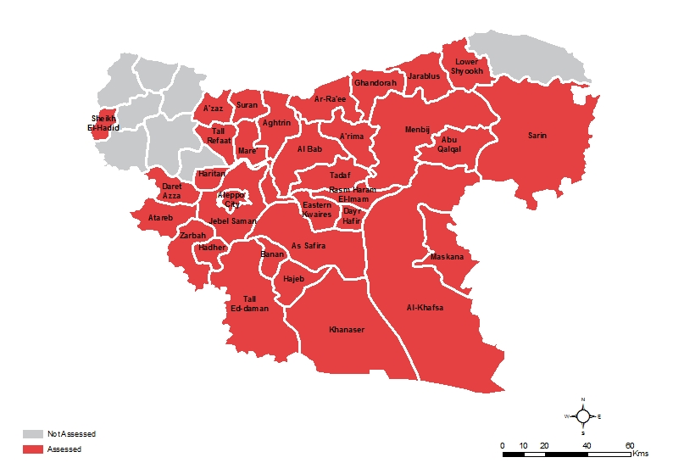

Across the humanitarian overview sections discussing food, safe water and health needs, this report presents an evaluation of the severity of sector needs recorded by field researchers and features a comparison with the sector severities recorded by the SINA conducted in November 2013. For the comparison to be valid, the present Aleppo Governorate assessment reuses the exact same severity scale as the one used in the SINA. For all sectors, a six-point scale has been thus used to assess the severities of humanitarian issues, in which level 1 is associated with minor and level 6 with catastrophic problems. In the scale, levels 1-3 are considered to be non-life threatening while levels 4-6 are considered to be life threatening. Based on the information provided by KI, field researchers had also the possibility to report no problem (level 0) for a given sector in a specific area. A slightly different severity scale is used for each sector, to allow for sector specificities, while the rationale is the same (Maps 5, 6, 7 & Figure 3).

Severities have been collected by REACH field researchers, based on direct observations and interviews with relevant KI. In the final analysis, humanitarian needs severities are however also partly a judgment call made by field researchers, based on the sector information they have collected in a given area. It should be noted that this approach, as it reused the SINA methodology, still largely suffers from the same limitations, notably heavily relying on field researchers’ consistency and thorough understanding of the methodology.

To maximally limit biases, the REACH team has specifically conducted a remote training with each field researcher to ensure that all of those involved in the process have a common and shared understanding of the definitions of the different levels of needs. Figure 3 is therefore presenting a general definition of the severities as they were explained to field researchers by the REACH team. All collected sector severities have also been cross-checked by local field researchers’ team leaders to again limit potential human biases and provide a second opinion on the per sector levels of severity recorded in each sub-district.

**Figure 3: General Severity Scale Used to Assess Sector Severities**

|  |  |
| --- | --- |
| Levels | Description |
| **6** | **Catastrophic situation for <sector name>.** Affected population faces life-threatening conditions causing high level of suffering, irreversible damages to health status and deaths. Large number of deaths are reported directly caused by the current <sector name> conditions and will result in many more deaths if no immediate <sector name> assistance is provided. |
| **5** | **Critical situation for <sector name>.** Affected population faces life-threatening conditions causing high level of suffering, irreversible damages to health status and deaths. Deaths are already reported, directly caused by the current <sector name> conditions, and more deaths are expected if no immediate <sector name> assistance is provided. |
| **4** | **Severe situation for <sector name>.** Affected population faces life-threatening conditions causing high level of suffering and irreversible damages to health, which can result in deaths if no humanitarian assistance is provided. |
| **3** | **Situation of major concern for <sector name>.** Majority of people are facing <Sector name> problems or shortages causing discomfort and suffering which can result in irreversible damages to health, but they are not life threatening. Affected population will not be able to cope with the <Sector name> current conditions if the situation persists and no humanitarian assistance is being provided. |
| **2** | **Situation of concern for <sector name>.** Many people are facing <sector name> problems or shortages causing discomfort and suffering, but they are not life threatening. Affected population is feeling the strain of the situation but can cope with the current situation with local resources. |
| **1** | **Situation of minor concern for <sector name>**, but conditions may turn concerning. Few people are facing problems or shortages in <sector name> but they are not life threatening. Affected population is feeling the strain of the situation but can cope with the current situation with local resources. |
| **0** | Normal situation for <sector name>. Population is living under normal conditions. All <sector name> needs are met. |

Despite all these checks and balances, the provided levels of sector severities are largely indicative and are based on qualitative information; this is even truer for the provided comparisons with the severity levels recorded by the SINA in November 2013. All the information on the sector levels of severity should thus be treated with care. Overall, levels of severities are only giving a general indication about the situation in a given sub-district and are, by nature, less reliable than the other findings presented in the humanitarian overview sections of the report.

As REACH is working to strengthen its assessment methodology, it is also extremely interested in refining and developing ways to better assess sector severities, so as to provide an easier and more reliable way to compare humanitarian needs across large geographical areas. With the assessment being a pilot one, REACH is also looking forward for addition inputs from humanitarian sectors working groups on how to better assess sector severities.

Throughout this report, a three-point scale is used to measure reliability. To ensure accuracy the accuracy of the collected data, field researchers thus ranked information’s reliability based on the records provided by KI, other evidence they reviewed, and the perceived reliability of the KI. With important security constraints hindering information collection in Aleppo Governorate, if not mentioned otherwise, the reliability level of the information provided by KI, notably for all population figures, is ranked 2 – the intermediate level. Some information with low reliability – ranked 3 – has been included in the displacement section, but it should be considered as indicative only.

Although the above measures were taken to assure highest possible accuracy of data, the displacement figures provided in the present report should be interpreted as estimates valid only as of mid-May 2014. Given the ongoing intense fighting between parties to the conflict in Aleppo Governorate and the high fluidity of displacement patterns, the displacement figures should be used with care as they may have significantly changed since May 2014.

Eventually, it should be noted that, since they are by nature a completely qualitative type of information, no reliability scale was used for the sector severities that could all be considered to be ranked with low reliability (level 3).

# Findings

## Displacement

Registering an estimated population of 4.9 million people prior to the conflict – with an estimated 1.5 million in the assessed areas excluding Aleppo City – Aleppo Governorate has been extensively affected by the ongoing fighting. Since the start of indiscriminate aerial shelling in As-Safira district in October 2013, the area has witnessed several successive waves of displacement. After indiscriminate shelling spread to the capital of the Governorate, Aleppo City in Jebel Saman sub-district, displacement intensified in December 2014. **An estimated 250,000 people have left eastern Aleppo City to relocate to other parts of Aleppo Governorate between January and early May 2014, an additional at least 100,000 people have fled from eastern Aleppo City between May and June 2014** ([REACH](http://reliefweb.int/sites/reliefweb.int/files/resources/Aleppo-City-Key-Informants-Assessment-Syria-Crisis.pdf), June 2014)[10]. Since January 2014, significant internal displacement in Aleppo Governorate was also triggered by ongoing inter-factional fighting across Menbij, A’zaz and Al Bab districts.As of early July 2014, large-scale fighting is continuing to trigger displacement in various parts of Aleppo governorate.

While this section will attempt to provide reliable IDP estimates across assessed areas, as well as information on displacement patterns, all numbers need to be considered with care. Across this displacement section, if not mentioned otherwise, the reliability level was reported to be 2 – the intermediate level on the three-point scale used to measure reliability – by field researchers. The provided figures are updated as of mid-May 2014, since when renewed displacement has occurred in Aleppo Governorate.

### **IDP Estimates in Assessed Sub-Districts**

KI from local authorities were asked to estimate the number of IDPs currently residing in their sub-districts. These numbers were then triangulated against available secondary data, including the SINA (Map 2).

The **sub-district reporting the highest number of IDPs** was reported to be **Menbij in Menbij district** with an estimated **137,000 IDPs**[11], followed by Atareb in Jebel Saman district with 90,000 IDPs; Maskana in Menbij district with 78,000 IDPs and Daret Azza in Jebel Saman district with 70,000 IDPs. Overall, **more than 629,000 IDPs were reported across 26 assessed sub-districts** (Map 2).

**Higher IDP numbers were reported in sub-districts to which a significant part of the population from eastern Aleppo City was displaced**: Jebel Saman district – the area closest to Aleppo City and Menbij district – an area in which IDPs from Aleppo City tended to have strong personal networks of family and friends ([REACH](http://reliefweb.int/sites/reliefweb.int/files/resources/REACH_NSyria_Report_CampsandITSAssessment.pdf), July 2014)[12].

**Map 2: Number of IDPs per assessed sub-district in Aleppo Governorate (Aleppo Governorate Assessment/** **SINA), November 2013 – May 2014[13]**

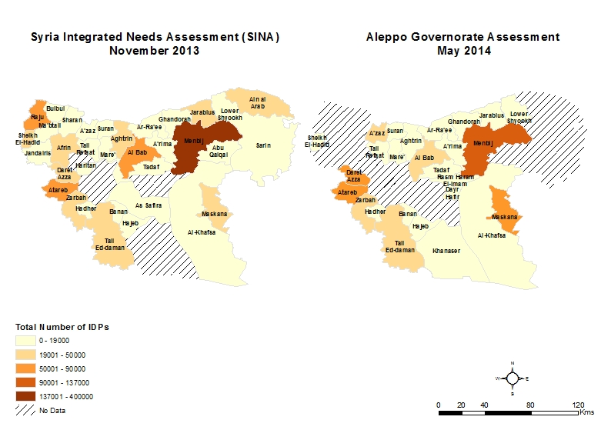

**Menbij district is hosting almost 225,000 IDPs**, over a third of all the IDPs reported in the Aleppo Governorate Assessment, suggesting it to be a major area of resettlement within Aleppo Governorate.Overall,higher numbers of IDPs are recorded in safer areas, away from main conflict hotspots, and in areas located closer to the border with Turkey where humanitarian aid is more easily accessible.

By contrasts, conflict-intensive sub-districts, as well as sub-districts where humanitarian access is curtailed and thus little humanitarian aid is being provided, host significantly fewer IDPs. The lowest numbers, with less than 4,000 IDPs being recorded, were reported in all three assessed sub-districts of As Safira district – Hajeb, Banan, Khanaser; two sub-districts in Al Bab district – Ar-Ra’ee and A’rima; two sub-districts in A’zaz – Aghtrin and Mare’; and Lower Shyookh sub-district in Ain Al Arab district. Amongst these, only Lower Shyookh sub-district is located near the Turkish border while most of these sub-districts have experienced high conflict over the past six months.

### **IDP Estimates in Assessed Sub-Districts: Comparison Aleppo Governorate Assessment/ SINA**

The IDP numbers presented in the Aleppo Governorate assessment were triangulated against the numbers featured in the SINA ([Assessment Working Group for Northern Syria](http://reliefweb.int/sites/reliefweb.int/files/resources/SINA_EN_Final.pdf), December 2013). The comparison should help identify trends and assess variations in IDP numbers at sub-district level, although these should be considered indicative since neither of the assessments was able to cover all of the sub-districts in Aleppo Governorate. In addition, some of the recorded IDP numbers in both assessments were of low reliability.

The SINA estimated the highest numbers of IDPs in Menbij sub-district, followed by Atareb, Maskana and Daret Azza sub-districts[14]. The same assessed sub-districts were thus found to host the majority of IDPs in Aleppo Governorate in both assessments. This suggests thatno major change in displacement patterns occurred between November 2013 and early May 2014 as recent IDPs appear to have favoured resettlement in the same areas as people who were displaced prior to the intensification of conflict in Aleppo City.

When considering only the sub-districts surveyed in both assessments, and excluding IDP estimates for Menbij sub-district which may have been overestimated during the SINA[15], the SINA recorded more than 352,000 IDPs across the 22 sub-districts that were assessed by both assessments in Aleppo Governorate. Comparatively, the present assessment estimated more than 448,000 IDPs across the same sub-districts, indicating an increase by an additional estimated 96,000 IDPs between November 2013 and early May 2014 in these areas.

The increase may be accounted for by additional displacement from eastern Aleppo City since January 2014. While the increase might have been expected to be more important taking into account the reported scale of the displacement, it was suggested during debriefings with field researchers that a significant part of IDPs from the capital who initially settled in Aleppo Governorate have since moved to safer areas in Syria or abroad, fleeing spreading insecurity. To a certain extent, this would suggest that even northern areas of Aleppo Governorate are seen as a transitory destination by a non-negligible number of IDPs.

### **Displacement Patterns**

Data on IDPs areas of origin was collected from interviewed KI, mostly representing local authorities. However, field researchers managed to gather reliable information for only half of the estimated 629,000 IDPs (Maps 3 & 4). Based on this information, only selected areas from within and from outside of Aleppo Governorate are featured in the analysis. These areas – from where a significant number of people have left since the start of the conflict – may be considered primary areas of origin for IDPs in Aleppo Governorate.

It should be noted that the following section considers an IDP’s area of origin to be his area of permanent residency immediately prior to the start of the conflict. This should allow the analysis to account for the facts that (1) important population displacement from rural to urban areas was ongoing in Syria before the conflict, (2) many IDPs have faced re-displacement following spreading conflict and (3) some IDPs have faced that could be labelled “stepped displacement”, transiting through other areas before arriving to places of current residence.

Factors Impacting on Displacement Patterns[16]

Increased conflict is the main factor triggering displacement in Aleppo Governorate ([REACH](http://reliefweb.int/sites/reliefweb.int/files/resources/REACH_NSyria_Report_CampsandITSAssessment.pdf), July 2014). As documented during debriefings, **IDPs are fleeing areas of high conflict intensity**, especially areas plagued by extensive aerial shelling, to relocate to safer area. When choosing areas of relocation, **IDPs are favoring areas where better living conditions are available**, not least because more **humanitarian aid is provided.** Apart from these two key factors, the choice of an area of relocation is also determined by additional factors that come into play to different extents.

* **Personal Networks:** IDPs are favoring for resettlement areas where they possess strong personal networks of relatives and friends that could help them integrate with the community and provide support ([REACH](http://reliefweb.int/sites/reliefweb.int/files/resources/REACH_NSyria_Report_CampsandITSAssessment.pdf), July 2014). IDPs also tend to perceive areas where they have strong personal networks as being safer, not least because these areas are better known to them. It should be noted that personal networks may be recent – built following recent displacement from the same area of origin, or more ancient – pre-dating the start of the conflict.
* **Available Resources:** IDPs have varying financial resources, a factor directly impacting on their ability to afford relocation costs. This impacts on the distance they are able to travel, the form of transportation, how much they can take with them, and eventually the type of settlement (rented accommodation, camp, collective centres, informal settlement) they can afford in areas of relocation ([REACH](http://reliefweb.int/sites/reliefweb.int/files/resources/REACH_NSyria_Report_CampsandITSAssessment.pdf), July 2014).
* **Distance from Area of Origin:** IDPs may be displaced at varying distances from their areas of origin. While for most IDPs this is not a determining factor, some IDPs are favoring short-distance displacement even if they could afford displacement to areas farther from conflict hotspots. Main reasons for this include the willingness to stay closer to their family, the perception that displacement is short-term and that they could return after conflict deescalated, and the need to return to their areas of origin often to earn/ collect money ([REACH](http://reliefweb.int/sites/reliefweb.int/files/resources/REACH_NSyria_Report_CampsandITSAssessment.pdf), July 2014).
* **Educational Background/ Skillset:** IDPs’ education and skillset determine their employability and capacity to earn the means to subsist in resettlement areas. IDPs who livelihoods are strongly linked to their areas of origin would then be more prone to stay closer to them, allowing them to often return ([REACH](http://reliefweb.int/sites/reliefweb.int/files/resources/REACH_NSyria_Report_CampsandITSAssessment.pdf), July 2014).

The conjunction of these factors is resulting in a situation where displacement in Aleppo Governorate is socially and culturally stratified first by areas of relocation and second by types of accommodation in areas of relocation ([REACH](http://reliefweb.int/sites/reliefweb.int/files/resources/REACH_NSyria_Report_CampsandITSAssessment.pdf), July 2014). Poorer and less educated IDPs are more heavily impacted by the defined additional factors than wealthier and more educated IDPs.

Poorer and less educated IDPs are heavily constrained in their choice of areas of relocation and are most likely to attempt displacement from their areas of origin as a last resort measure. In areas of relocation, they are also limited in their choice of accommodation, favoring less expensive informal settlements to camps[17]. Wealthier and more educated IDPs have less to worry about financial resources, personal networks’ support, their employability in areas of arrival and preserving strong ties with their areas of origin. This group can then maximize the two key factors: better security and living conditions.

**Four areas have been determined as being primary areas of origin for IDPs within Aleppo Governorate: Aleppo City in Jebel Saman sub-district, rural Jebel Saman sub-district, As Safira sub-district, and Al Bab sub-district.** Over the past six months, these areas have experienced conflict that triggered important displacement.

IDPs from Areas of Origin in Aleppo Governorate

**The bulk of internal displacement in Aleppo Governorate was triggered by people leaving from As Safira sub-district and Aleppo City, mostly toward Menbij sub-district.** As reported during debriefings with field researchers, up to 90% of the remaining population in As Safira district was composed of combatants in late April 2014, after most of the civilians had fled. In parallel, over 50% of all the population in eastern Aleppo City, at least 400,000 people, has fled the area since January 2014 ([REACH](http://reliefweb.int/sites/reliefweb.int/files/resources/Aleppo-City-Key-Informants-Assessment-Syria-Crisis.pdf), June 2014).

Displacement patterns from As Safira and Aleppo City appear to be quite similar while displacement in both cases was triggered by the start of aerial shelling, in October 2013 in As Safira and in December 2013 in Aleppo City. **Apart from Menbij district, IDPs from both areas have relocated to neighboring sub-districts in Jebel Saman, As Safira and Al Bab districts, as well as to A’zaz and Jarablus districts** in the north of the governorate (Map 3).

For IDPs from Al Bab and rural Jebel Saman (excluding Aleppo City) sub-districts, trends are quite different. Three sub-districts were identified as areas of relocation for IDPs from Al Bab with most of the IDPs leaving toward A’zaz sub-district; fours sub-districts were identified as areas of relocation for IDPs from rural Jebel Saman, with most of the IDPs leaving toward Daret Azza and Atareb sub-districts in Jebel Saman district[18].

**Map 3: Primary areas of origin of IDPs from Aleppo Governorate as of May 20****14[19]**

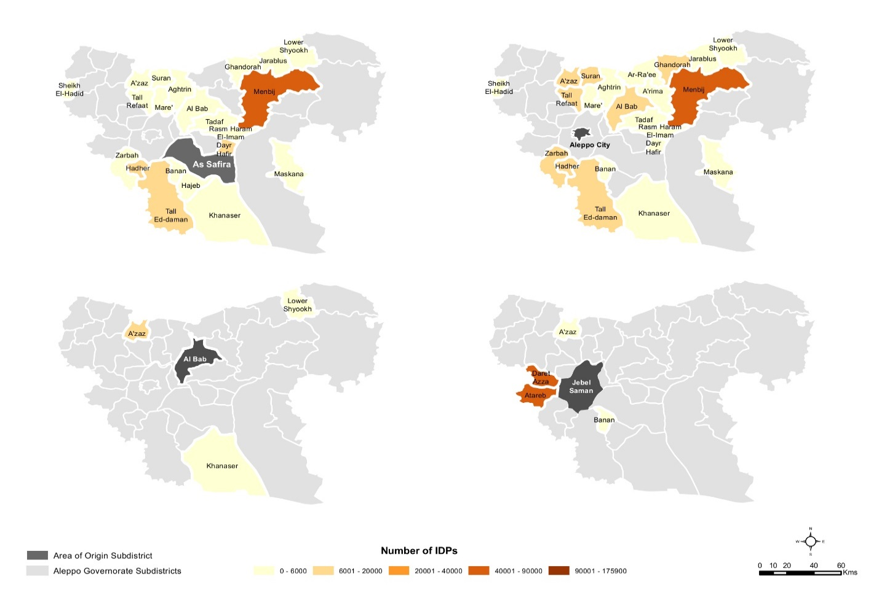

Taking all this into account, three major displacement trends in Aleppo Governorate may be identified: displacement to Menbij District, displacement to A’zaz and Jarablus districts and short-distance displacement.

**Displacement to Menbij District[20]:** Massive displacement to Menbij was recorded for IDPs from As Safira and Aleppo City while no IDPs from Al Bab and rural Jebel Saman have left to this area[21]. Controlled by a third-party radical armed group, most of Menbij district was considered relatively safe as of late April 2014, despite protection issues being reported during debriefings[22].

To date, the area has also been spared aerial shelling. However, Menbij district is not located on the border with Turkey and although humanitarian aid is provided in the area, it is less well-covered than districts further north.

Prior to the conflict, Menbij was an important area of origin for people living in Aleppo City and As Safira sub-district ([REACH](http://reliefweb.int/sites/reliefweb.int/files/resources/REACH_NSyria_Report_CampsandITSAssessment.pdf), July 2014). Given the strength of personal networks, only reinforced with each additional wave of displacement, many IDPs from Aleppo and As Safira favored resettlement in Menbij to rely on the support of family and friends. The cultural link may have been reinforced by the fact that a non-negligible part of IDPs from eastern Aleppo had only relatively recently moved from rural to urban areas prior to the conflict, according to information collected during debriefings.

Since January 2014, most of the displacement from Aleppo City came from the opposition-controlled east of the city, an area formerly known as the “crescent of the poor” ([REACH](http://reliefweb.int/sites/reliefweb.int/files/resources/Aleppo-City-Key-Informants-Assessment-Syria-Crisis.pdf), June 2014). Similarly, rural As Safira district was also not a particularly wealthy area prior to the conflict. In parallel, as of early May 2014, Menbij district was hosting an estimated 26 informal settlements, the highest number across Aleppo Governorate. In addition, 80% of the informal settlements in Menbij were established since October 2013 when aerial shelling in As Safira started ([REACH](http://reliefweb.int/sites/reliefweb.int/files/resources/REACH_NSyria_Report_CampsandITSAssessment.pdf), July 2014).

While an overwhelming majority of IDPs from Aleppo City and As Safira have limited financial resources, they are favoring resettlement at lower costs in informal settlements and not in camps near the border[23]. **The multiplication of informal settlements in Menbij district since October 2013 is thus a by-product of massive displacement of poorer population groups from eastern Aleppo City and As Safira, as well as the direct consequence of the lack of affordable housing in the area.**

**The fact that Menbij district registered as the area with the most IDPs in the SINA and the Aleppo Governorate assessment attests to the strength and consistency of the factors attracting IDPs to this area.** As displacement is socially stratified in Syria, each new wave of IDPs from Aleppo City is composed of poorer IDPs, people who were heavily impacted by the conflict and eventually forced to leave despite having little means to do so. Wealthier population groups had the opportunity to resettle abroad or to camps on the Turkish border before fighting in Aleppo City reached such intensity. Against this background, the attractiveness of Menbij is reinforced for new IDPs due to a strong cultural factor and to the affordability of informal settlements.

The fact that Menbij district is located closer to Jebel Saman and As Safira districts than the northern areas may also have played a role for some IDPs who did not want to move too far away from their areas of origin.

**Displacement to A’zaz and Jarablus Districts:** Some IDPs from all areas of origin, including a more important number from Aleppo City and Al Bab sub-district, have left toward one of these two districts. Controlled by opposition groups for A’zaz and by a radical third-party armed group for Jarablus, these two areas remain attractive in terms of security[24]. While the level of available of humanitarian aid in Jarablus is comparable to Menbij[25], more humanitarian aid is available in A’zaz where humanitarian access is less constrained.

As of May 2014, 6 camps, regrouped in Bab al-Salameh camp cluster in A’zaz sub-district and Jarablus camp cluster in Jarablus sub-district ([REACH](http://reliefweb.int/sites/reliefweb.int/files/resources/REACH_NSyria_Report_CampsandITSAssessment.pdf), July 2014), existed across the two districts. Being better organized than informal settlements and receiving regular humanitarian, camp clusters provide significantly better living conditions for IDPs than informal settlements.

**Wealthier IDP groups from Aleppo City, as well as rural from Jebel Saman, As Safira, and Al Bab districts have thus resettled to areas along the Turkish border, where camps are established and more relief aid is provided**[26]. It may be assumed that these IDPs also possess strong personal ties with IDPs already living in these areas. Eventually, some of them are probably in a transit situation, planning to move to Turkey in the mid-term.

As displacement is ongoing in Aleppo Governorate, it is gradually affecting less and less wealthy people, who have already resettled. As a direct consequence, this may lead to less direct displacement to camps in border areas and more displacement to informal settlements in areas farther away from the Turkish border. By contrast, the parallel dynamic of people leaving camps to resettle abroad may however allow some IDPs from informal settlements to move into camps in border areas.

**Short-Distance Displacement:** Across all areas of origin, some IDPs have resettled to areas located close to their areas of origin. In particular, this trend may be noted for IDPs from rural Jebel Saman sub-district who all resettled in areas directly adjacent to the area of origin. Most of these resettlement areas, although as not as conflict intensive as Aleppo City or As Safira, cannot be considered completely safe as of late April 2014[27].

Given the relative security they offer, it might be argued that resettlement of IDPs to these areas is triggered by several factors. As for the Menbij area, it may be argued that they are favored by IDPs who have personal ties, relatives or friends, in these sub-districts. Besides, these areas are all located closer to areas of displacement, suggesting that the cost of relocation is even inferior than the relocation to Menbij district.

This may point toward these areas being predominantly favored by poorer IDPs that relocate to informal settlements, such as across Jebel Saman district ([REACH](http://reliefweb.int/sites/reliefweb.int/files/resources/REACH_NSyria_Report_CampsandITSAssessment.pdf), July 2014)[28], in areas just out of conflict frontlines. Eventually, short-distance displacement is likely to allow these IDPs to often travel back to their areas of origin to visit family, work or collect money, as reported during debriefings with field researchers.

IDPs coming from Areas of Origin outside Aleppo Governorate

KI also reported that a significant number of IDPs in Aleppo Governorate were originating from other parts of Syria before the conflict (Map 4). Most of the out of Aleppo Governorate IDPs are coming from Homs Governorate which has witnessed significant fighting and the prolonged siege of the governorate capital over the past six months.

**Two major trends may be identified for these IDPs: displacement to Jarablus, A’zaz districts and Menbij districts, and displacement to Jebel Saman district for IDPs from Idleb governorate.**

**Displacement to Menbij A’zaz, Jarablus Districts:** IDPs who originated from other governorates, with the notable exception of IDPs from Idleb governorate, are mostly found in northern sub-districts. These are areas closer to the Turkish border that host camps and informal settlements and where aid is provided by local and international humanitarian actors. As their personal networks in Aleppo Governorate are more limited, IDPs from other governorate are mostly interested in the security situation and the level of provision of humanitarian aid when choosing a place for relocation.

IDPs from Homs and Rural Damascus are mostly found in Menbij district, with smaller numbers being notable in sub-districts in Jarablus and A’zaz districts. While small amounts of IDPs from Ar-Raqqah, Hama and Damascus have been recorded in Aleppo Governorate, these are also found in the northern areas, particularly in Jarablus district.

**Displacement to Jebel Saman District:** The dynamic is only notably different for IDPs originating from Idleb governorate who, though some may also be found in Jarablus and A’zaz sub-districts, mostly stay in areas neighbouring their governorate of origin, notably Zarbah and Tall Ed-daman sub-districts in Jebel Saman district, areas that recorded relatively high numbers of IDPs (Map 4).

Reasons for this may be diverse, but according to debriefings with field researchers, most of the IDPs from Idleb governorate are from eastern parts of the governorate and tend to favour displacement to neighbouring areas because of existing family or community ties. Displacement to Jebel Saman district is a then form of short-distance displacement that allows them to often return to Idleb governorate to visit family, work or collect/ transfer money.

**Map 4: Primary areas of origin of IDPs out of Aleppo Governorate a****s of May 2014**

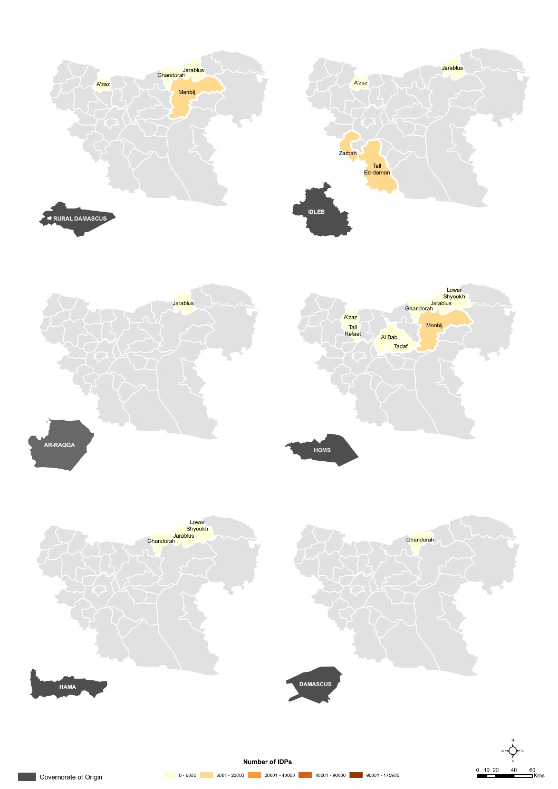

## Food

To allow for comparability with the SINA conducted in November 2013 ([Assessment Working Group for Northern Syria](http://reliefweb.int/sites/reliefweb.int/files/resources/SINA_EN_Final.pdf), December 2013), the same severity scale was used to measure the severity of needs in food across assessed sub-districts in the present assessment. Information on severity was collected from relevant KI who assessed the severity of food needs in their respective sub-districts on a six-level scale, ranging from 0 (“there are not shortages”) to 6 (“as a result of food, many people have already severe malnutrition”)[29]. In the used scale, levels 1 – 3 are considered to be not immediately life threatening while levels 4 – 6 are considered to be life threatening. It should be noted that severity levels is a qualitative type of information that is very difficult to estimate for KI and that it remains indicative (Figure 3).

Data on eastern Aleppo City is only featured in the severity map, it has been excluded from the following analysis and figures since the area was assessed separately, although not for the food sector ([REACH](http://reliefweb.int/sites/reliefweb.int/files/resources/Aleppo-City-Key-Informants-Assessment-Syria-Crisis.pdf), June 2014). All figures in the food section have been aggregated at district level, however this aggregation remains indicative as not all sub-districts have been assessed for each presented district and the aggregation was done without weighting by sub-districts population because of population figures low reliability (Map 5).

**Map 5: Food needs severity per assessed sub-district in Aleppo Governorate, Novem****ber 2013 – May 2014[30]**

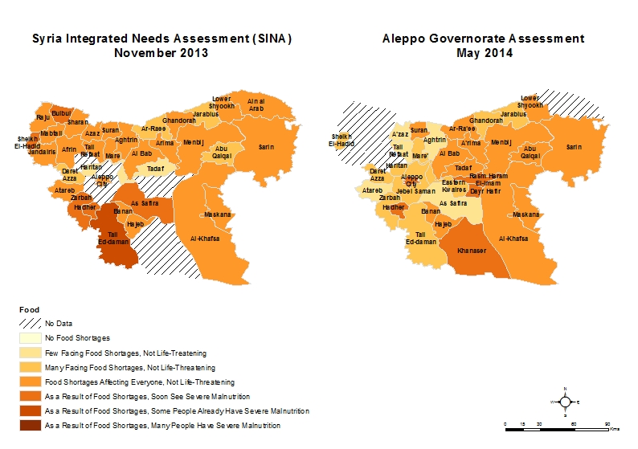

### **Severity of Food Needs**

With no KI reporting a food severity level of less than 2, **all assessed sub-districts in Aleppo Governorate are currently facing extensive food shortages.** Highest food severity levels were identified for Dayr Hafir and Rasm Haram El-Imam sub-districts in Al Bab district, Khanaser sub-district in As Safira district and Hadher sub-district in Jebel Saman district. Apart from the conflict plagued eastern Aleppo City area for which the severity score is provided only indicatively, these four sub-districts were the only ones to record a severity level of 5 (“as a result of food shortages, some people already suffer from severe malnutrition”) in Aleppo Governorate. In addition, 13 other sub-districts located across Al Bab (5 sub-districts), Menbij (4 sub-districts), As Safira (2) and Ain Al Arab (2) districts recorded severity level 4 (“as a result of food shortages, we will soon see severe malnutrition”), also classified within the life threatening category. On the other end, lowest food severity levels were recorded for 5 sub-districts, located across A’zaz (3 sub-districts), Jebel Saman (1) and As Safira (1) districts, where KI reported that “many people were facing shortages, but they are not life-threatening” (level 2).

**The food security situation is significantly impacted across assessed sub-districts of Aleppo Governorate by a range of factors including: the level of conflict, the level of access, the distance from the Turkish border, the population density and the number of IDPs** (Map 2)**, and the level of urbanization.** These factors are impacting on the price of food products and may drive food insecurity up in areas where the population is heavily reliant on markets for food.

The sub-districts most affected by food insecurity according to KI are the ones which struggle simultaneously with several issues, spawning across notably Menbij district – the area with by far the highest number of IDPs, Jebel Saman, As Safira and Al Bab districts – conflict-intensive areas not located along the Turkish border and where, in addition, humanitarian access is severely curtailed. The majority of the sub-districts most affected by food insecurity tend thus to cumulate several of the followings issues: conflict hotspot, remote, urban, hard-to-reach for humanitarian actors because of distance or insecurity, and densely populated with large numbers of IDPs.

By contrast, three of the lowest levels for food security (level 2) were recorded in A’zaz district while all of Jarablus district recorded level 3 (“food shortages are affecting everyone, but they are not life-threatening”) according to local KI. These districts are the ones were the only two IDPs camps clusters in Aleppo Governorate are located while informal settlements are dominating in other districts. A’zaz and Jarablus are also both adjacent to the Turkish border, receive significant humanitarian aid and are not high conflict areas.

Interestingly enough, As Safira sub-district in As Safira district and Atareb sub-district in Jebel Saman district, along with several other sub-districts in Jebel Saman, recorded only level 2 severity. To explain low levels of recorded food insecurity in these areas, it is possible to suggest that the relative depopulation these areas faced due to increased conflict since November 2013[31], notably As Safira and areas around Aleppo City, have led to a decreased pressure on resources, including food products.

### **Severity of Food Needs: Comparison Aleppo Governorate Assessment/ SINA**

Conducted in November 2013, the SINA registered highest levels of food insecurity for Tall Ed-daman sub-district in Jebel Saman district (level 5), followed by Zarbah, Hadher and Jebel Saman sub-districts also in Jebel Saman district, Bulbul and Sheikh El-Hadid sub-districts in Afrin district – not assessed in the present assessment, and As Safira sub-district in As Safira district. Taking into account sub-districts featuring in both assessments, only Hadher sub-district in Jebel Saman district features as one of the most affected in both assessments.

On the other end, the SINA registered lowest levels (levels 1 and 2) of food insecurity for Jebel Saman, Darret Azza and Haritan sub-districts in Jebel Saman district, Tadaf and Ar-Raee in Al Bab district, Abu Qalqal in Menbij district, and Jarablus sub-district in Jarablus district. None of these has been recorded among the least affected sub-districts in the Aleppo Governorate assessment. By contrast to the Aleppo Governorate assessment, the SINA even recorded food severity level 1 (“a few people are facing food shortages, but they are not life threatening”) in two sub-districts.

Overall, if the SINA recorded generally higher levels of food insecurity in Jebel Saman district,KI in the present assessment reported **on average higher levels of food insecurity across assessed sub-districts of Aleppo Governorate, showing a worsening of the situation with access to food since November 2013**. For instance, KI for the present assessment reported food severity level 4 for Tadaf sub-districts in Al Bab district and Abu Qalqal sub-district in Menbij district, areas reported among the ones with the lowest severities levels in the SINA.

Across Aleppo Governorate, generally increased food insecurity amidst surging conflict appear coherent, notably in conflict intensive and hard-to-reach areas. By contrast, improved food security in several area located closer to the Turkish border, notably Sheikh El-Hadid sub-district in Afrin district, as well as Tall Refaat and Aghtrin sub-districts in Azaz district, may probably be explained by the provision of humanitarian aid.

Eventually, in line with the conclusions of the previous section that detailed food severity levels in Aleppo Governorate, two other trends may help account for differences in least and most affected areas between the two assessments. **Extensive and ongoing population movements may have shifted the balance with several sub-districts receiving new large number of IDPs that may have resulted in increased food insecurity since January 2014.** For instance, food insecurity appear to have worsened across Al-Khafsa, Maskana, and Menbij sub-districts of Menbij district, where increased demographic pressure may have overstretched food supply. In parallel, **displacement from heavily affected areas, notably Jebel Saman and As Safira districts, may have consequently decreased the pressure on food commodities in these areas.**

### **Functioning of Bakeries**

KI assessed the status of bakeries in each sub-district, classifying them as non-functioning as a result of conflict (non-functioning (damaged)), non-functioning for other reasons (non-functioning (other)) and functioning (Figure 4)[32].

**Figure 4: Status of bakeries in assessed districts of Aleppo** **Governorate, May 2014**



**Only KI in Jebel Saman, As Safira and Jarablus districts reported that some bakeries were non-functioning as a result of conflict damage.** Amidst all non-functioning bakeries, only KI in Hajeb and Khanaser sub-districts in As Safira district and KI in Daret Azza sub-district in Jebel Saman district reported that most were not functioning because of conflict-damage.

Across the 21 other sub-districts, KI reported that the majority of non-functioning bakeries were non-functioning for other reasons than conflict-damage (Figure 4 & 5). Apart from the three conflict intensive areas, **conflict-damage thus does not appear to be a major reason for bakeries non-functioning.** Eventually, it is also important to note that, across all assessed districts apart from As Safira, half or more of the pre-conflict bakeries are still functioning.

KI have also been asked to specifically select reasons for bakeries to have closed from a provided list (Figure 5). In line with the findings above, KI reported that the vast majority of assessed non-functional bakeries are no longer functional for reasons other than conflict-related damage. Only in As Safira and Jebel Saman, two of the most high conflict intensity areas, KI reported that respectively 20% and 9% of bakeries have closed because of destruction due to conflict[33].

**Figure 5: Reasons for bakeries to have closed in assess****ed districts of Aleppo Governorate, May 2014[34]**



KI have stressed the **lack of key ingredients (flour, wheat, yeast) as a primary reason for bakeries closing** with all districts, for instance, reporting lack of ingredients as a problem. In assessed areas of Menbij, Afrin, Ain Al Arab and A’zaz districts – all relatively low conflict intensity areas, at least 50% of non-functioning bakeries have closed because of shortage in ingredients. Across Al Bab, As Safira, Jarablus and Jebel Saman, at least 25% of non-functioning bakeries have closed because of shortage in ingredients. The lack of ingredients (wheat, flour, yeast) was especially heavily reported in some assessed sub-districts. For instance, in Al-Khafsa and Maskana sub-districts in Menbij district and in Tall Refaat sub-district in Azaz district, KI indicated that these shortfalls are actually the only reason affecting the functioning of bakeries. Shortages in key ingredients may be **explained by various reasons, including financial constraints impeding bakeries’ ability to purchase these ingredients, difficulties of access and transport of these ingredients to conflict-affected areas where access is curtailed and/ or shortfalls in production** as prolonged conflict has impacted on the country’s agricultural potential.

Eventually, KI in Afrin, Ain Al Arab, As Safira, and Jarablus have to different extents mentioned the lack of fuel as a reason for bakeries closing while KI in A’zaz have reported the lack of electricity and KI in Jebel Saman have mentioned both problems (Figure 5)[35]. In Sheikh El-Hadid, the only assessed sub-district in Afrin district, the lack of fuel and electricity accounts for 50% of the reported reasons why bakeries cannot function adequately. **This points toward shortages in power, being it fuel or electricity, as an important reason for infrastructure to be less functional across conflict-plagued northern Syria**[36].

### **Food Availability**

KI were asked to rank the top-three problems impacting on food availability in each sub-district (Figure 6 & Annex).

**Figure 6: Food availability issues in assessed districts of Alepp****o Governorate, May 2014**



KI have reported the **lack of infant formula as a major problem with KI in A’zaz, Afrin, Al Bab, Jarablus and Menbij districts** ranking it as their main problem. For instance, all KI in assessed sub-districts, except Khanaser in As Safira district, Menbij in Menbij district, and Daret Azza in Jebel Saman district, reported the lack of infant formula as one of the top two critical issues in terms of food availability. Apart from the lack of infant formula, KI from **all districts, except Jebel Saman**,have also reported the **lack of cooking fuel** with KI in Ain Al Arab and Menbij ranking it as their main problem. Together the lack of infant formula and the lack of cooking fuel, have been reported by 50% or more of KI in A’zaz, Afrin, Ain Al Arab, Jarablus and Menbij districts and by over 50% of KI in Al Bab.

In the Health section, KI largely reported growth monitoring/ nutrition surveillances services as being among the least covered services in assessed sub-districts, a problem likely to exacerbate the issue with the lack of infant formula. Aghtarin and A’zaz sub-districts in A’zaz district and in Atareb sub-district in Jebel Saman district, appear to be acutely affected by both low growth monitoring service coverage and food shortages affecting children.

In parallel, KI from several districts have stressed the **impact of the conflict on the local food production, the loss of agricultural cultivated land, the loss of agricultural assets/ inputs, and the loss of livestock.** Over 30% of KI in Afrin, Al Bab, As Safira, and Jebel Saman districts have reported a combination of these problems. The problem seems to be especially acute in As Safira district where over 60% KI have reported a combination of these issues, stressing especially the lack of local food production.

It should also be noted that apart from Ain Al Arab district, where only the scarcely populated Lower Shyookh sub-district was assessed,KI did not massively report the lack of food products available on markets.The issue was only reported by 20% or less KI from Jebel Saman, A’zaz and Al Bab districts.

### **Access to Food**

KI were asked to rank the top-three problems impacting on access to food in each sub-district (Figure 7 & Annex).

Apart from heavily conflict affected As Safira district where all sub-districts – Banan, Hajeb, Khanaser – mentioned the problem, physical and logistics constraints food on access were not mentioned by KI from other districts. Only a small number of KI in all, solely in As Safira district and KI in Ar-Ra’ee sub-district in Al Bab district, mentioned security constraints as a problem impacting on food access.

For instance, KI in Jebel Saman, which is located on the southern edge of the governorate and whose assessed areas have the strongest severity index, did not report physical or security constraints as being the main challenge in accessing food. Instead, **KI from all districts have massively reported different types of economic constraints on access to food**. The finding is in line with the previous section that suggested that, across assessed areas, food is generally available in markets.

**Figure 7: Food access issues in assessed districts of A****leppo Governorate, May 2014**



**KI have massively reported the lack of resources to purchase food as major constraint on access to food,** the answer being selected as the top reason by KI from all sub-districts except Al Bab and Tadaf in Al Bab district and Aghtarin in A’zaz district**.** Such a strong prevalence suggest that **economic constraints are a major impediment to access food in northern Syria** with the population struggling to purchase food from markets. This finding may be correlated with the above section outlining reasons for bakeries to be non-functioning. **The high inflation on all food products, including ingredients for bread production, is likely driving food insecurity across assessed areas.**

**The fact that the second most reported answer by KI was the impossibility to purchase specific types of food – mentioned by KI from all areas except As Safira – further stresses the importance of financial constraints on accessing food.** The differentiation between the two options is important to emphasize. The fact that most KI chose to first rank a more radical answer suggests that a significant part of the population, the most vulnerable and poorer part, does not have the needed resources to purchase food at all while another less affected group is unable to purchase certain types of food. It is interesting to correlate this with the findings of the previous section that outlined that the lack of infant formula, a specific and more expensive type of food, was considered to be a key issue across assessed areas.

As in the previous section, a significant number of KI stressed the lack of resources to purchase cooking fuel, confirming the idea that the lack of fuel appear to be an important problem across assessed sub-districts, especially in Tall Ed-daman, Zarbah, Hadher in Jebel Saman district, Tall Refaat, Mare', and Aghtrin sub-districts in A’zaz district, Al Bab and Tadaf sub-districts in Al Bab district and Ghandorah sub-district in Jarablus district.

### **Markets Stocks**

KI were asked to provide information on available stocks of food products and NFIs in markets in each sub-district (Figure 8). **Except in As Safira district**,KI have reported that **markets have all or most of the required stocks**. In As Safira,KI in two of the three sub-districts – Hajeb and Khanaser – reported a critical situation in terms of food security, with no available markets as of late April 2014.

**Figure 8: Local market stocks in assessed districts** **of Aleppo Governorate, May 2014**



In line with these previous findings, KI reported that **most local traders are able to replenish their stocks within 7 days, should they sell out their remaining stock**[37]. Only in the districts of Al Bab and As Safira, traders were struggling to replenish their stocks, with less than 70% of traders in Al Bab being able to replenish stocks within a week. Furthermore, markets in A’rima, Dayr Hafir and Soran sub-districts, in Al Bab, along with Banan sub-district, in As Safira, only have part of their required stock, and traders’ difficulties in replenishing stocks is likely worsening an already dire situation.

Overall, information provided by KI strongly suggests that **economic reasons are the main issue impacting on food availability and on access to food across assessed sub-districts of Aleppo Governorate.** While markets have some stocks, the majority of the population struggles to purchase food at large, specific types of food or cooking fuel. It may be also argued that inflation is probably also impacting on bakeries, constraining their ability to purchase key ingredients to produce bread, and forcing some of them to close.

## Water

**To allow for comparability with the SINA conducted in November 2013** ([Assessment Working Group for Northern Syria](http://reliefweb.int/sites/reliefweb.int/files/resources/SINA_EN_Final.pdf), 31/12/13), **the same severity scale was used to measure the severity of needs in safe water across assessed sub-districts in the Aleppo Governorate assessment.** Information on severity was collected from relevant KI who assessed the severity of safe water needs in their respective sub-districts on a six-level scale, ranging from 0 (“all safe water needs are met”) to 6 (“as a result of shortages in safe water, many people have already died”)[38]. In the used scale, levels 1 – 3 are considered to be not immediately life threatening while levels 4 – 6 are considered to be life threatening. It should be noted that severity levels is a qualitative type of information that is very difficult to estimate for KI and that it remains indicative (Figure 3)

Data on eastern Aleppo City is only featured in the severity map, it has been excluded from the following analysis and figures since the area was assessed separately with findings on water needs being presented in the Aleppo City Key Informants Assessment report ([REACH](http://reliefweb.int/sites/reliefweb.int/files/resources/Aleppo-City-Key-Informants-Assessment-Syria-Crisis.pdf), June 2014). All figures in the water section have been aggregated at district level, however this aggregation remains indicative as not all sub-districts have been assessed for each presented district and the aggregation was done without weighting by sub-districts population due to population figures low reliability (Map 6).

### **Severity of Water Needs**

As no KI reported a water severity level below 2, **populations in all assessed sub-districts in Aleppo Governorate are currently facing extensive drinking water shortages.** Highest drinking water severity levels were identified in several sub-districts of Jebel Saman district, including Hadher, Haritan, Tall Ed-daman, and Zarbah, as well as in the sub-districts of Mare’ in Azaz district, Khanaser in As Safira district, and Soran in Al Bab district. Besides Jebel Saman district, likely affected by water shortages in April and May 2014 ([REACH](http://reliefweb.int/sites/reliefweb.int/files/resources/Aleppo-City-Key-Informants-Assessment-Syria-Crisis.pdf), June 2014), these three sub-districts were the only ones to record a severity level of 5 (“as a result of shortages in drinking water, some people have already died”) in Aleppo Governorate. Additionally, nine other sub-districts located across Al Bab (2 sub-districts), As Safira (2), Azaz (3), and Jebel Saman (2, including Eastern Aleppo City), recorded severity level 4 (“as a result of shortages in drinking water, we will soon see some people die”), also classified within the life threatening category.

On the other end, lowest drinking water security levels were recorded for three sub-districts, located in Al Bab (1 sub-district) and Jarablus (2), where KI reported that “many people are facing shortages in drinking water, but they are not life-threatening” (level 2). Overall, the majority (14) of the assessed sub-districts was facing shortages in drinking water affecting everyone, although these shortages were not considered to be life-threatening (level 3).

**Map 6: Safe water ne****eds severity per assessed sub-district in Aleppo Governorate, November 2013 – May 2014[39]**

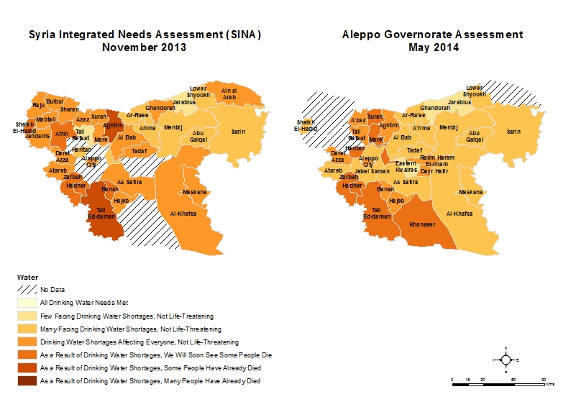

Issues related to drinking water provision across assessed sub-districts of Aleppo Governorate tend to be impacted by various factors, notably the **intensity of conflict** which **affects electricity supply to pumping stations and consequently the functioning of the whole water networks**[40]. Various other factors impact on the availability of and the access to drinking water, including the demographic pressure and number of IDPs, the level of urbanisation and coverage by the water network, the proximity to alternative water sources, be it wells or rivers, the availability of containers, the availability of fuel and the availability of chlorination products.

The districts – Jebel Saman, As Safira and Al Bab – hosting, according to KI, the most affected sub-districts in terms of drinking water shortages usually cumulate several concomitant problems. They are conflict-intensive and located farther from the Turkish border, where humanitarian aid delivery is more limited. Parts of these areas are also rural, likely having more difficulties to access the water network, which is the main source of safe drinking water across assessed areas of northern Syria. They all experience important shortages in electricity supply, notably As Safira and Jebel Saman.

The assessed areas where KI reported lower, not life-threatening levels of drinking water issues, varying from “many people are facing shortages in drinking water, but they are not life-threatening” (level 2) to “shortages in drinking water are affecting everyone, but they are not life-threatening” (level 3), are located mostly in Jarablus (2 sub-districts), Menbij (4 sub-districts), and Ain Al Arab (2 sub-districts). All of these areas are closer to the Turkish border and, although they tend to host significant number of IDPs, they are not conflict-intensive areas. Both proximity to Turkey and reduced conflict intensity allow for regular humanitarian aid delivery. It might be suggested that these areas are likely to also have better access to alternative water sources.

Along with those sub-districts, KI indicated lower levels of drinking water shortages for rural Jebel Saman and Atareb sub-districts in Jebel Saman district, and for As Safira sub-district, in As Safira district. Lower levels may be here correlated to the relative depopulation of these areas, especially in As Safira and the vicinity of Aleppo City, following increased conflict since November 2013[41] that likely reduced pressure on water resources.

### **Severity of Water Needs: Comparison Aleppo Governorate Assessment/ SINA**

Conducted in November 2013, the SINA registered highest levels of drinking water shortages for Tall Ed-daman sub-district, in Jebel Saman (level 5), followed by Jebel Saman, Zarbah, and Hadher sub-districts, also in Jebel Saman, along with Sheikh El-Hadid sub-district, in Afrin district, and As Safira sub-district, in As Safira district (level 4). Taking into account sub-districts featured in both assessments, only Tall Ed-daman appears to be affected by the highest level of recorded severity (level 5) in both the SINA and the Aleppo Governorate assessment. On the other end, the SINA registered lowest levels (levels 1 and 2) of drinking water shortages for Aleppo City, Daret Azza and Haritan sub-districts in Jebel Saman district, Tadaf and Ar-Ra’ee sub-districts in Al Bab district, Abu Qalqal sub-district in Menbij district, as well as Jarablus sub-district in Jarablus district. None of these, with the exception of Jarablus sub-district, has been recorded as the least affected sub-district in the present assessment. By contrast to the Aleppo Governorate assessment whose KI did not report a water severity level below 2, the SINA recorded drinking water severity level 1 (“a few people are facing shortages in drinking water, but they are not life-threatening”) in two sub-districts.

Overall, if the SINA recorded generally higher levels of drinking water shortages in several sub-districts in Afrin, As Safira, and Jarablus, KI for the present assessment reported **on average higher levels of drinking water shortages across assessed sub-districts of Aleppo Governorate**, emphasising a **worsening of drinking water shortages since November 2013.** For instance, KI for the Aleppo Governorate assessment reported that the severity of drinking water shortages in Haritan and Daret Azza sub-districts, both located in Jebel Saman, has become life-threatening (levels 4 & 5), with deaths directly linked to these water shortages being reported in Haritan sub-district (level 5). Both areas had been reported to have the lowest severity levels (1 & 2) in the SINA.

Across Aleppo Governorate, an overall increase in drinking water shortages may be explained by **prolonged conflict** that impacts on the functioning of the water infrastructure and **reduced humanitarian access to certain areas**. By contrast, improvements in areas closer to the Turkish border, namely Ghandorah sub-district in Jarablus district and Sheikh El-Hadid in Afrin district, are likely related to the provision of safe drinking water by humanitarian actors. Three **additional factors** that impact on drinking water availability may also be outlined. **Population movements** may have played a role in worsening or improving the drinking water situation across the Governorate. Areas already affected by drinking water shortages are thus likely to see their drinking water supply overstretched as a result of large arrivals of IDPs. Conversely, lower severity levels would be observed in areas affected by drinking water shortages in late 2013, but where demographic pressure has recently decreased. **Increased conflict intensity** in districts such as Jebel Saman, As Safira and Al Bab may have impacted water networks and reduced drinking water supply as a result. Eventually, most of Aleppo Governorate was affected by a **drought** this year[42] that has likely impacted on the availability of water through both the network and alternative sources. To a large extent, the prolonged drought may also lead to a further increase of water shortages in the coming months.

### **Main Water Issues**

Answering about their priority concerns regarding water, KI in each sub-district ranked the three following issues: access to water, availability of water, and quality of water (Figure 9).

**Figure 9: Major Water issues in assessed districts of Aleppo** **Governorate, May 2014**



KI responses vary across assessed sub-districts, depending notably on such factors as the local security situation, population density, proximity to a water source, level of access for humanitarian actors. In Afrin, Jarablus, As Safira and A’zaz, KI ranked availability of water as being the most pressing issue. In Al Bab, Jebel Saman (excluding Aleppo City), and Ain Al Arab districts, KI all reported access to water as the most pressing issue, but however disagreed on the ranking of the two remaining problems. Ki in Menbij were eventually the only ones to rank water quality as their most pressing issue, followed respectively by access to water and availability of water.

Eventually, it should be stressed that KI from Al Bab and Tadaf in Al Bab district, as well as KI from Menbij in Menbij district, have reported that there was no major issue with water in their areas[43].

### **Water Quality, Storage & Price**

KI also highlighted specific issues related to water quality, storage and price, having to pick and rank three issues within a list provided in the assessment questionnaire (Figure 10 & Annex).

**Figure 10: Issues impacting water quality, storage & price in assessed distric****ts of Aleppo Governorate, May 2014**



While some trends may be identified, situations vary across assessed sub-districts of Aleppo Governorate (Figure 10). It is however worth pointing to which extent KI answers have covered almost all of the listed issues, spreading widely, with, for instance, KI from sub-districts in Al Bab district reporting all of the available issues to different extents.

KI from all districts, except Afrin for which only Sheikh El-Hadid sub-district was assessed, mentioned the **use of unsafe water** sources as an issue, showing to which extent the problem is widespread. Similarly, KI from all districts, except Jarablus and Menbij, mentioned **increased water prices** as an issue. Both issues likely point toward water network deficiencies as the latter is the main source for free and safe drinking water in the assessed areas. Alternatively, people are forced to rely on other water sources which are not always safe or to buy water for the ones who can afford it.

The choice made in favor of the “use of unsafe water sources” option instead of the “water unsafe for drinking option” by KI in a majority of districts – except A’zaz where the two options are mentioned evenly, As Safira where the second option is more reported and Afrin where neither of the options is reported – tends to suggest that in these areas **multiple water sources are available and, at least part of them, are considered to be safe**. The high prevalence of this option in KI responses is likely also related to **the deficiency of the water network.**

The relatively low numbers of KI stressing water quality issues, with “water does not taste good” only being reported as the main option by KI in Ain Al Arab where only Lower Shyookh sub-district was assessed, suggests that these are not priority concerns, confirming that **the problem lies more with access to safe water than its quality**.

### **Water Availability**

Reports from KI also highlighted specific issues related to water availability which gives a particular insight in the problems outlined in the previous section. While some trends may be identified, situations also vary across assessed sub-districts (Figure 11 & Annex). However, it is possible to notice that for water availability, KI answers are clustered around some specific options.

**Figure 11: Issues impacting availability of water in assessed districts of Alep****po Governorate, May 2014**



KI from all districts except Afrin, stressed the **lack of electricity to operate the water system** among their main problems. The option ranked first in Al Bab, Menbij, Jarablus, and Ain Al Arab sub-district, second in Jebel Saman and A’zaz, and third in As Safira. The impression that the water availability issues is clearly related to the deficiency of the water network is reinforced by the relatively high prevalence of the two other answers related to the network: “water system overstretched” (ranked first in A’zaz and Afrin, second in Al Bab and Jarablus) and “water system deficient” (ranked first in As Safira)[44]. Eventually, the answer “lack of fuel for generators” was also reported (ranking second in Al Bab, Jarablus, Ain Al Arab, and third in Jebel Saman) suggesting that the lack fuel, an alternative power source to electricity, to run the network could also be a major problem.

Such answers by KI may be related to the previous section and support the argument that the **deficiencies of the water network across various areas is the main factor leading to curtailed access to safe water.** The main factor impacting on the functioning of the water network appears them to be the **intermittent and unreliable power**, be it electricity or fuel, supply. As in the previous section, the need for water storage containers was also widely reported as a problem. A possible explanation for this high prevalence would be the important need of water containers to accumulate safe water when the latter is available through the network.

### **Access to Water**

KI were asked to highlight specific issues related to access to water, having to pick and rank three among four the provided following options: logistical and physical constraints, lack of money/ resources to buy water, security constraints, and other which had to be specified (Figure 12).

**Figure 12: Issues impacting on access to water in assessed districts of Alep****po Governorate, May 2014**[45]



The “other” option has not been widely used by KI, being only reported from Afrin, Al Bab, As Safira and Jebel Saman. Besides, only two different problems were specified as other: the lack of reservoirs and the lack of electricity, both of which had already been largely reported in other questions about safe water. All three remaining options were mentioned rather evenly in A’zaz, Al Bab, Jebel Saman, and to a lesser extent in Ain Al Arab, As Safira, Jarablus districts suggesting that all these factors participate in making access to water challenging. The lack of money option was not mentioned at all in Afrin district.

The main priority in each area seems to be dependent on the local situation while most KI reported all three problems. Specifically, logistical and physical constraints have been reported as the main factor impacting on access to water in Afrin and As Safira districts while the lack of money was reported as the main factor in Al Bab and Jebel Saman districts. In Jarablus district, both options were reported evenly. Eventually, security constraints were reported as the main factor impacting on access to water in A’zaz and Ain Al Arab districts.

Overall, information provided by KI strongly suggest that **main water issues are related to the local operability of the water network** which is the main sources of safe water. The water network system is in turn widely affected by the lack of power, fuel or electricity. Given the scarcity of alternative safe water sources, a series of concomitant problems then arises for this main issues, including the lack of water storage containers and the inflation affecting drinking bottled water. To a large extent, it may be safely assumed that these problems are affecting first and foremost the poorer population groups that lack personal power generators to pump water and resources to buy water.

## Health

To allow for comparability with the SINA conducted in November 2013 ([Assessment Working Group for Northern Syria](http://reliefweb.int/sites/reliefweb.int/files/resources/SINA_EN_Final.pdf), December 2013), the same severity scale was used to measure the severity of needs in the health sector across assessed sub-districts in the present assessment. Information on severity was collected from relevant KI who assessed the severity of health needs in their respective sub-districts on a six-level scale, ranging from 0 (“all heath needs are met”) to 6 (“as a result of shortages in health services, many people have already died”)[46].

In the scale, levels 1 – 3 are considered to be not immediately life threatening while levels 4 – 6 are considered to be life threatening. It should be noted that severity levels is a qualitative type of information that is very difficult to estimate for KI and that it remains indicative (Figure 3).

Data on eastern Aleppo City is only featured in the severity map, it has been excluded from the following analysis and figures since the area was assessed separately with findings on health needs being presented in the Aleppo City Key Informants Assessment report ([REACH](http://reliefweb.int/sites/reliefweb.int/files/resources/Aleppo-City-Key-Informants-Assessment-Syria-Crisis.pdf), June 2014). All figures in the health section have been aggregated at district level, however this aggregation remains indicative as not all sub-districts have been assessed for each presented district and the aggregation was done without weighting by sub-districts population due to population figures low reliability (Map 7).

**Map 7: Health needs severity per assessed sub-district in Aleppo Governorate, November** **2013 – May 2014[47]**

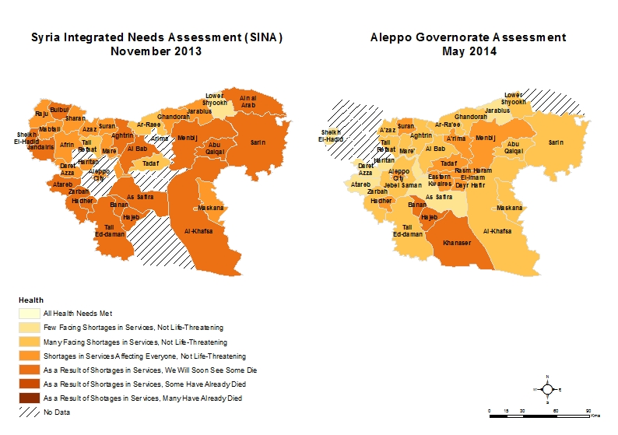

### **Severity of Health Needs**

Across assessed sub-districts, no KI reported a severity lower than 2 (“many people are facing shortages in health services, but they are not life threatening”) suggesting that people in the whole assessed area are currently facing **widespread shortages in health services**. Highest severity levels for health needs were identified in Banan, Hajeb and Khanaser sub-districts – all located in As Safira district, which recorded level 5 (“as a result of shortages in health services, some people have already died”). An additional 9 sub-districts, located across Al Bab (6 sub-districts), Jebel Saman (2, including eastern Aleppo City) and Menbij (1) districts, recorded severity level 4 (“as a result of shortages in health services, we will soon see some people die”).

On the other end, lowest severities for health needs (level 2: “many people are facing shortage in health needs, but they are not life-threatening”) were recorded in Atareb, Daret Azza and Haritan sub-districts in Jebel Saman district, in As Safira sub-district in As Safira district, and in Jarablus sub-district in Jarablus district.

With conflict being widespread in Aleppo Governorate, **shortages in health services** in various sub-districts are **triggered by** factors such as the **exodus of qualified medical specialists**, the **lack of equipment and funding**, the **lack of access for aid actors, conflict damages to health centres,** the **increased demographic pressure in areas to which many IDPs have relocated,** the **pre-conflict low medical services coverage in remote areas** which are now cut from urban centres due to conflict.

The three sub-districts for which KI reported highest severity for health needs are located in As Safira district which has witnessed increased conflict since October 2013, being also targeted by aerial shelling, and consequent massive exodus of people to other areas. High severities for health needs were also recorded in all Al Bab sub-districts, except Ar-Ra’ee, and two Jebel Saman areas, Hadher and Eastern Aleppo City. These are all areas where conflict has surged over the past six months and where a significant part of the population, including clearly the most qualified part of the population, such as medical specialists, was displaced. The above mentioned areas are also all located farther from Turkey, making the provision of relief by humanitarian actors challenging if not altogether impossible. Eventually, high health needs being registered in Menbij sub-district are not surprising as the area is, by far, the one hosting the largest number of IDPs in Aleppo Governorate, having received large numbers of IDPs from Aleppo City.

Regarding the sub-districts for which KI have reported the lowest levels of health needs: if low levels of health needs being recorded in the Jarablus area are not so surprising, the reported low health needs severity levels in several sub-districts in Jebel Saman district, as well as in As Safira sub-district, are more difficult to explain. A possible explanation would be to argue that the population exodus from these area over the past six months has decreased the pressure on health services with the remaining population having now reduced health needs.

The recorded intermediate levels 3 (“shortages in health services are affecting everyone, but they are not life threatening”) severity of health needs, notably in areas along the Turkish border, would tend to suggest that **the situation with health services provision is on the brink of becoming extremely severe in a whole range of sub-districts where currently everyone is affected by shortages,** but a minimum level of basic healthcare is still being provided, probably with the support of humanitarian actors**.**

### **Severity of Health Needs: Comparison Aleppo Governorate Assessment/ SINA**

Conducted in November 2013, the SINA registered highest levels of severity (level 4) for health needs in 17 sub-districts located across Jebel Saman (4 sub-districts), Afrin (3), Menbij (3), As Safira (3), Ain Al Arab (2), Al Bab (1) and A’zaz (1) districts. Taking into account sub-districts covered in both assessments, **Hajeb and Banan in As Safira district, Hadher in Jebel Saman district and Menbij in Menbij district were ranked among the most affected areas in both the SINA and the Aleppo Governorate assessment** (Map 7).

On the other end, the SINA registered lowest levels of health needs’ severity for Tadaf and Ar-Ra’ee sub-districts in Al Bab district, Tall Refaat in A’zaz district and Lower Shyookh in Ain Al Arab district. None of these has been recorded among the least affected sub-districts in the present assessment. By contrast, the SINA has also recorded only severity levels 2 and 3 across eastern Aleppo City while the Aleppo Governorate assessment has recorded a severity level of 4 according to information provided by KI.

Overall, if the SINA recorded generally higher levels of severity for health services across assessed areas of Aleppo Governorate, it is not necessarily an indication of a decrease in health needs as reliability for severity measures may be debated for both assessments(Map 7)[48]. Overall, while an amelioration of the health situation in sub-districts bordering Turkey can be attributed to increased humanitarian aid, a general amelioration across Aleppo Governorate is more difficult to explain, notably across several remote and conflict-intensive areas.

The explanation used in the other sections suggesting that population displacement has decreased the pressure on overstretched services in several conflict-intensive areas cannot be valid for all areas. If it may work for As Safira sub-district for which health needs severity has decreased from level 4 to level 2, it seems less relevant for areas such as Menbij district that hosts large numbers of IDPs and Al Bab district where conflict is surging.

**Relying on qualitative information collected from debriefings with field researchers and secondary sources, the situation with regard to health needs appears to be dire across Aleppo Governorate and is clearly not improving, especially in hard-to-reach areas for humanitarian actors.** As will be detailed in the rest of the health section, different health services coverage remains, for instance, very low across of Aleppo Governorate.

### **Functioning of Health Centres**

Following months of conflict and prolonged aerial shelling, health facilities have been significantly impacted by the ongoing conflict (Figure 13).

**Figure 13: % of damaged and not damaged health centres per assessed** **d****istrict in Aleppo Governorate, May 2014[49]**



**Health facilities have been badly damaged in areas recording heavy aerial shelling or ground fighting such as Jebel Saman (62% of damaged health facilities), As Safira (60%) and A’zaz (43%) districts.** This is confirmed in secondary sources that point to widespread aerial strikes against health facilities in urban centres, such as Aleppo City, Tal Refaat and Al Bab cities, in Aleppo Governorate since the beginning of the conflict ([PHR](https://s3.amazonaws.com/PHR_syria_map/web/index.html#.U3EuE_ldU-c), March 2014). By contrast, health centres in areas that have not been severely affected by conflict or are located closer to Turkey, such as in Ain Al Arab, Al Bab and Menbij districts, have been less affected[50].

KI were then asked to select and rank in each assessed sub-district the top-3 reasons for which health centres are less functional (Figure 14). Similarly as for Aleppo City ([REACH](http://reliefweb.int/sites/reliefweb.int/files/resources/Aleppo-City-Key-Informants-Assessment-Syria-Crisis.pdf), June 2014), **conflict-related damage does not appear to be among the main factors impacting the functioning of health centres in Aleppo Governorate**.

**Figure 14: Main reasons for health centres being less functional per assessed district in Aleppo Gove****rnorate, May 2014**



Conflict-related damage as one the top-three reasons for health centres to be less functional has only been mentioned by KI in As Safira and A’zaz districts, respectively all three assessed sub-districts in As Safira (Banan, Hajeb, and Khanaser) and two of the four assessed sub-districts in A’zaz (A’zaz and Tall Refaat). These are two of the three areas where the highest percentage of health centres was damaged (Figure 13). Interestingly enough, conflict-related damage has not been mentioned by KI from Jebel Saman where the highest percentage of damaged health centres has been recorded while KI from the area were the only ones to mention lack of electricity as a reason for the reduced functioning of health centres.

For all the other districts, other reasons have been mentioned by KI to account for the reduced functioning of health centres. Such reasons as the **lack of funding, the lack of medical equipment, the lack of medical staff, and the lack of medicine** have been featuring the most prominently in KI’s responses. This points toward the fact that these other factors are mainly responsible for the current weakness of the healthcare system in Aleppo Governorate.

### **Main Health Issues**

KI were asked to select and rank the top-3 principal health problems within a list of proposed options. While main health priorities[51] tend to vary across the different districts in Aleppo Governorate, logically reflecting different security situations, different levels of access to health services, as well as various population densities and concentration of IDPs, some general trends may also be outlined (Figure 15 & Annex).

**Conflict-related injuries management** feature prominently as one of the main health concernsas reported by KI, especially in several conflict-intensive areas such as the Jebel Saman and A’zaz districts. In Jebel Saman, KI from the two most affected sub-districts in terms of health, Zarbah and Hadher, as well as KI from Tall Ed-daman, all reported conflict-related injuries as their main concern. Ki from A’zaz and Mare’ sub-districts in A’zaz district have done the same. Besides, KI across Aleppo Governorate have consistently reported chronic diseases to be among their main health concerns. According to debriefings with field researchers, this situation is to be related to the general weakness of the health system and the documented lack of advanced specialized health care in Aleppo Governorate (Figure 16) that is primarily impacting on the management of complex health problems that need intensive and regular care.

**Figure 15: Most reported health problems per assessed district in A****leppo Governorate, May 2014**



KI from a majority of districts have reported **leishmaniasis,** an ulcerous communicable skin and mouth disease spread by certain types of flies, appear to currently be an endemic problem in Syria. The high prevalence of leishmaniasis may be compounded by several factors such as the clustering of the population due to displacement and the lack of adequate shelter and/ or the lack of nets treated with insecticide. In fact, leishmaniasis is indeed most reported in highly populated districts such as Menbij where KI from all sub-districts – Al-Khafsa, Maskana, and Menbij – have ranked it as their main health problem.

By contrast, **fever and psychological trauma** have never been reported amidst the most acute health issues. To a certain extent, this may be related to the difficulty to identify fever as a separate health problem while it is often collateral to the development of a more severe health condition and the difficulty to diagnose severe psychological trauma in a situation where a significant part of the population is likely to be already affected.

Eventually, reported main health issues also reflect the particular situations in each area. If in Menbij, Jebel Saman, Al Bab, and A’zaz districts leishmaniasis together with conflict-related injuries and chronic diseases account for more than 70% of the problems reported by KI, priorities are quite different in other parts of Aleppo Governorate.

In Jarablus district, maternal health issues together with respectively acute respiratory infections and diarrhoea account for 75% of the most reported health issues. As opposed to the rest of the Governorate where only KI in As Safira district mentioned the problem, the importance of maternal health issues in Jarablus (33% of KI answers) which was stressed by KI from both sub-districts – Ghandorah and Jarablus, may be related to the weakness of maternal healthcare in the area, as well as to the high population density as Jarablus is hosting a large number of IDPs, especially younger IDPs and women. In the Food section, KI from Jarablus district had also reported the lack of infant formula as their main food availability issue.

In Ain Al Arab, where Lower Shyookh sub-district was the only area assessed, measles together with leishmaniasis account for over 80% of the health concerns. In Afrin, Sheikh El-Hadid sub-district being the only assessed area, severe disease affecting children under 5 years old together with communicable diseases account for more than 80% of the health concerns. Eventually, it appears that in As Safira, across the scarcely populated assessed sub-districts of Banan, Hajeb and Khanaser, main health issues are not clearly identified as KI reported a wider range of health problems while it was also the only district where KI mentioned malnutrition as an issue, even ranking it as their main concern.

### **Health Services’ Coverage**

KI from among Health Officials estimated the percentage of coverage of different health services compared to what would be needed given the current increased caseload. As reported by KI, most of health services across sub-districts in Aleppo Governorate are recording poor levels of coverage (Figure 16 & Annex).

**Figure 16: % Health services’ coverage per districts in Aleppo Gove****rnorate, May 2014[52]**



Apart from Ain Al Arab district, where only Lower Shyookh sub-district was assessed and KI only reported gaps in vaccination and emergency healthcare, KI from all districts in Aleppo Governorate reported **significant health coverage gaps across all services.**

Excluding Ain Al Arab district, **gaps are especially acute for such services as management of chronic diseases** – all other districts recording less than 20% of coverage, **growth monitoring and nutrition surveillance** – all other districts recording less than 15% coverage, **medicine distributions** – all other districts recording 25% or less coverage, **emergency health services and ambulances** – all other districts recording 34% or less coverage. Throughout the assessed areas, only vaccination services appeared to be at least partly well covered following vaccination campaigns conducted by humanitarian partners as reported during debriefings with field researchers.

Across all assessed sub-districts – excluding Ain Al Arab district and vaccination services, only medical consultations in Menbij and Jebel Saman districts recorded over 50% coverage, all the other services recorded less than 50% coverage when data was aggregated at district level.

**The situation seems to be especially dire in the conflict-affected As Safira district** – Banan, Hajeb, and Khanaser sub-districts – where all services, excluding vaccination (32%), recorded 12% or less coverage according to KI[53]. Similarly, **in Jarablus distric**t – Ghandorah and Jarablus sub-districts – all services, excluding vaccination, recorded 25% or less coverage. Eventually, **in A’zaz district** – A’zaz, Aghtarin, Mare’ and Tall Refaat sub-districts, excluding vaccination, all other services record 30% or less coverage.

Overall, information provided by KI strongly suggests a dire situation in Aleppo Governorate with regard to health needs. In severely conflict-prone areas, such as Jebel Saman, As Safira and A’zaz, the high amount of damages sustained by health facilities may be driving health needs up, but the main problems seems to be related to the lack of medicine, medical equipment and staff that hinder the provision of more advanced healthcare across all areas. The situation is especially acute in the densely populated areas located farther from the Turkish border where humanitarian access is constrained. Eventually, the problems most reported by KI among their priorities – chronic diseases, conflict-related injuries, and leishmaniasis – remain among the less covered health services in Aleppo Governorate.

# Conclusion

Between January and May 2013, Aleppo Governorate, especially its northwestern parts, has been a flashpoint of the Syrian war with several areas facing ground fighting between armed parties and/ or aerial shelling. Protracted conflict in Aleppo Governorate has led to massive displacement that impacted heavily on the population repartition across sub-districts, as well as to surging humanitarian needs. As the security situation in Aleppo Governorate is worsening on a daily basis as of mid-July 2014 and Aleppo City is threatened by siege, it is likely that the humanitarian situation will continue to deteriorate, resulting in further displacement.

Assessing the situation across 26 sub-districts, this report recorded an estimated **over 629,000 IDPs, including 137,000 IDPs in Menbij sub-district alone.** Menbij was also estimated to contain the highest number of IDPs in the Syria Integrated Needs Analysis (SINA) conducted in November 2013. In parallel, four areas within Aleppo Governorate – Aleppo City, As Safira sub-district, rural Jebel Saman sub-district and Al Bab sub-district were identified as being primary areas of origin for IDPs in Aleppo Governorate. Quantitatively speaking however, most of the IDPs were displaced from Aleppo City where conflict has intensified over the past six months.

If conflict appears to be the main trigger for displacement and an important factor, together with the levels of aid provision in resettlement areas, REACH identified several additional factors influencing the choice of relocation areas. IDPs tend to favor areas where they possess strong personal networks and areas where they are able to economically afford relocation. Consequently, **most IDPs from eastern Aleppo City and As Safira – the two main areas of origin – were displaced toward Menbij district where they had personal ties and were able to afford relatively cheap housing in informal settlements.**

Comparing levels of severity of needs with those provided in the SINA,this report shows that **severity levels for food and safe water have on average increased across assessed areas of Aleppo Governorate since November 2013.** In both cases, this report suggest that the increase is not so much triggered by conflict-related damage as by other factors that may vary across sub-districts. The lack of a reliable power supply has been identified as a main issue impacting on the functioning of the water network and thus the availability of safe-drinking water. Economic constraints appear to be the main factor hindering access to food.

Regarding health, this report has not identified significantly increased severity levels of needs compared to the SINA. However, it has identified **significant gaps in health services coverage across all sub-districts in Aleppo Governorate with very few essential health services registering over 50% of coverage.** Conflict-related injury management, chronic diseases and leishmaniasis are currently the main health problems in Aleppo Governorate. Although conflict damage to health facilities is widespread, the functioning of health centres is primarily affected by the lack of funding, medical equipment, medical staff and medicine.

With humanitarian access being curtailed, notably to hard-to-reach areas, there is an **urgent need to provide relief aid to conflict-affected populations, especially in areas which may soon become inaccessible to aid actors.** With food being consistently reported as the priority sector by affected populations, **assistance should include in-kind and direct cash-transfer assistance to affected populations.**

With humanitarian information being scarce and not consolidated, notably on displacement levels and IDP population figures, there is an urgent need **to** **identify areas of concentration of displaced populations**. To further support the humanitarian response, REACH will continue to monitor the situation in Aleppo Governorate and to provide updated population figures. Addressing widespread information gaps on the Syrian crisis, REACH will also release a series of reports as part of an effort to document displacement and humanitarian needs in key urban centres in Northern Syria, including an update on Aleppo City, building on the [Aleppo City Key Informants Assessment](http://reliefweb.int/sites/reliefweb.int/files/resources/Aleppo-City-Key-Informants-Assessment-Syria-Crisis.pdf) released in June 2014.

# Annex

## Food: Additional Figures

**Figure 17: Food availability issues** **in assessed sub-districts of Aleppo Governorate (1)**



**Figure 18: Food availability issues in assessed sub-districts of Aleppo G****overnorate (2)**



**Figure 19: Food access issues in assessed sub-districts of** **Aleppo Governorate (1)**

**Figure 20: Food access issues in assessed sub-****districts of Aleppo Governorate (2)**



## Water: Additional Figures

**Figure 21: Issues impacting water quality, storage & price in assessed sub-districts of** **Aleppo Governorate (1)**



**Figure 22: Issues impacting water quality, storage & price in assessed su****b-districts of Aleppo Governorate (2)**



**Figure 23: Issues impacting availability of water in asse****ssed sub-districts of Aleppo Governorate (1)**



**Figure 24: Issues impacting availability of water in assessed** **sub-districts of Aleppo Governorate (2)**



## Health: Additional Figures

**Figure 25: Most reported health problems per assessed sub-district in Aleppo** **Governorate, May 2014 (1)**



**Figure 26: Most reported health problems per assessed sub-district in A****leppo Governorate, May 2014 (2)**



**Figure 27: % Health services’ coverage per sub-di****stricts in Aleppo Governorate, May 2014 (1)**



**Figure 28: % Health services’ coverage per sub-distric****ts in Aleppo Governorate, May 2014 (2)**



1. Menbij sub-district was also covered by both assessments, but is excluded from this comparison. The IDPs estimates for Menbij sub-district in the SINA are extremely high with the number likely being overestimated.
2. “Syria: Mapping the conflict”, [BBC](http://www.bbc.com/news/world-middle-east-22798391), 13/04/2014.
3. *Human Right Watch* reported that, according to a local monitoring group, attacks have killed over 2,300 civilians in Aleppo governorate between November 1, 2013, and March 21, 2014 (“Syria: Unlawful Air Attacks Terrorize Aleppo”, [HRW](http://www.hrw.org/news/2014/03/24/syria-unlawful-air-attacks-terrorize-aleppo), 24/03/14).
4. “Syrian troops advance in key city of Aleppo”, [Al Jazeera](http://www.aljazeera.com/news/middleeast/2014/07/syrian-troops-advance-key-city-aleppo-201477152123692491.html), 07/07/2014.
5. Since late April 2014, Government forces’ advance in Aleppo City have triggered massive displacement to other parts of Aleppo Governorate (Aleppo City Key Informants Assessment ([REACH](http://reliefweb.int/sites/reliefweb.int/files/resources/Aleppo-City-Key-Informants-Assessment-Syria-Crisis.pdf), June 2014).
6. The Aleppo Governorate assessment was only able to collect IDPs population estimates for 26 sub-districts in Aleppo Governorate.
7. Districts and sub-districts delimitations in Aleppo Governorate have changed to a limited extent in 2008 and 2009. However, similarly to the Syria Integrated Needs Analysis (SINA) ([Assessment Working Group for Northern Syria](http://reliefweb.int/sites/reliefweb.int/files/resources/SINA_EN_Final.pdf), December 2013), this report uses the old district and sub-district delimitation, registering 40 sub-districts overall. For instance, this report treats the Dayr Hafir district created in 2008, and the sub-districts it includes, as part of Al-Bab district. While the old delimitation is still mostly referred to by the local population, Aleppo Governorate has now officially 46 sub-districts. Overall, it should be noted that, if KI have a good understanding of delimitations at sub-district level, most of them have a poor knowledge of district level divisions.
8. Field researchers also collected data on the sectoral severities of needs in Jebel Saman sub-district, separately for Aleppo City and rural Jebel Saman. The data on the severities of needs in Aleppo City is thus different from the one provided in the Aleppo City Key Informants Assessment report released in June 2014.
9. This map presents all the areas for which information was collected for the Aleppo Governorate assessment, including the areas for which only information on the sectoral severity of needs in food, water and health was collected.
10. In mid-February, WFP reported that over 450,000 people were estimated to have fled from eastern Aleppo following surging violence. The figure included an estimated 200,000 people who fled to the western neighborhoods of the city, 250,000 people who fled to other areas of Aleppo Governorate, and approximately 2,000 who fled towards the Turkish border ([WFP](http://reliefweb.int/sites/reliefweb.int/files/resources/WFP%20Syria%20Crisis%20Aleppo%20Displacement.pdf), 18/02/14).
11. The number for Menbij sub-district was determined by triangulating the number provided by local authorities (175,000 IDPs) with lower estimates provided by several international NGOs delivering aid in the area. From available secondary information, it was calculated that the actual estimate should be closer to the number provided in this report (137,000). It however still remains indicative.
12. Across the whole section, this report distinguishes camps and informal settlements based on the definition provided in the Camps and Informal Settlements in Northern Syria report ([REACH](http://reliefweb.int/sites/reliefweb.int/files/resources/REACH_NSyria_Report_CampsandITSAssessment.pdf), July 2014). An informal settlements is thus an aggregation of IDPs into *ad hoc* settlement, usually inside Syria, and is different from an IDP camp-like settlement near the border that is named camp in common humanitarian discourse and recognized by the Camp Coordination and Camp Management (CCCM) humanitarian cluster.
13. The relatively high IDPs number recorded in the SINA for Al Bab sub-district was discarded because of the lack of reliability of the data. It is provided on map 2 as an indication only, and should be treated as having a reliability level of 3 – the lowest level on the reliability scale used by both assessments.
14. The relatively high IDPs number recorded in the SINA for Al Bab sub-district was discarded because of the lack of reliability of the data.
15. The SINA estimated that 400,000 IDPs were residing in Menbij sub-district, a number being overestimated according to humanitarian organizations involved in Menbij.
16. Since no area controlled by the Government of Syria has been assessed, this section only discusses displacement patterns in opposition-controlled areas.
17. Security may also be a factor pushing some IDPs to choose informal settlements over camps. Despite inter-factional warfare in Azaz, Menbij, Al Bab and Jarablus districts, informal settlements have been largely unaffected due to their rural location. By contrast, the Bab Al Salameh border camp group in A’zaz was targeted for car bombing in February by unknown parties ([REACH](http://reliefweb.int/sites/reliefweb.int/files/resources/REACH_NSyria_Report_CampsandITSAssessment.pdf), July 2014).
18. Atareb was made into a separate district in December 2008. In the Aleppo Governorate assessment, it is however included in Jebel Saman district as this delimitation is still mainly used by KI.
19. For displacement from Jebel Saman sub-district, Aleppo City is excluded as it is analyzed in a separate map. Regarding the Map analyzing displacement from Aleppo City, the data collected was not able to take into account displacement from Aleppo City to rural Jebel Saman which is likely to represent a significant number of IDPs.
20. Only the opposition-controlled part of Menbij district is discussed here. This includes the north of the district with Menbij sub-district.
21. As reported during debriefings with field researchers, displacement from Aleppo City toward Menbij has significantly increased in late April.
22. Protection issues such as child recruitment and enforcement of radical Islamic laws in areas controlled by radical third party groups were reported during debriefings.
23. Many official camps, often managed by a group of people, are thus demanding entry fees from new IDPs.
24. Some fighting between third party groups was reported and ongoing in parts of Jarablus, but it had largely receded as of late April following local ceasefires according to debriefings. Most of the areas in this two districts are mostly safe, although fighting is reportedly ongoing in parts of both districts, notably in Aghtarin sub-district in A’zaz.
25. It was reported during debriefings that less IDPs are now moving to Jarablus than to A’zaz, notably because more humanitarian aid is provided in A’zaz camps.
26. Apart from IDPs leaving to border areas, a significant part of the population left directly to Turkey. As reported during debriefings, IDPs leaving directly to Turkey are the wealthiest part of the population, an estimated 25% of all IDPs across all assessed sub-districts.
27. During debriefings, it was, for instance, reported that a large number of poorer IDPs from Jebel Saman resettled to Dayr Hafer sub-district as the area is mostly sparred aerial shelling and is located closer. A high number of poorer IDPs also resettled in Jebel Saman itself despite security concerns with some informal settlements having reportedly been targeted by aerial shelling in March – April 2014.
28. Jebel Saman district was also reported to host a significant number of informal settlements during debriefings with field researchers.
29. The provided information should be used with care (See methodology section). The data for food needs severity levels was collected separately from the main assessment with field researchers conducting specific interview with KI to determine sectoral severity levels in sub-districts. For some areas for which field researchers were unable to conduct a complete assessment because of heavy access constraints, only severity levels were collected from KI.
30. The Aleppo Governorate assessment and the SINA are not covering exactly the same sub-districts because of significant access constraints due to increased conflict across Aleppo Governorate since the beginning of the year. Figure 1 & 2 and Map 1 in the methodology section detail the areas covered in the present assessment.
31. Even if several sub-districts in Jebel Saman district host a significant number of IDPs, located notably in informal settlements, the overall population of the area is likely to have still significantly decreased.
32. Tadaf sub-district in Al Bab district was discarded because of the lack of reliability of the collected data.
33. It should be noted that assessed sub-districts in As Safira are amongst the smallest and least populated areas.
34. No KI has used the “other” option provided in the questionnaire used during the assessment.
35. Tadaf sub-district in Al Bab district was discarded because of the lack of reliability of the collected data.
36. According to information provided in the Aleppo City Key Informants Assessment Report, the lack of power source is probably the primary factor impacting on the functioning of bakeries in eastern Aleppo City ([REACH](http://reliefweb.int/sites/reliefweb.int/files/resources/Aleppo-City-Key-Informants-Assessment-Syria-Crisis.pdf), June 2014).
37. “Do Not Know” answers accounted for 20% of the answers KIs provided to this question.
38. The provided information should be used with care. (See methodology section). The data for safe water needs severity levels was collected separately from the main assessment with field researchers conducting specific interview with KI to determine sectoral severity levels in assessed sub-districts. For some areas for which field researchers were unable to conduct a complete assessment because of heavy access constraints, only severity levels were collected from KI. Eventually, information for safe water severity levels in Aleppo City was re-collected separately for this map and is thus different from the one recorded in the Aleppo City Key Informants Assessment Report ([REACH](http://reliefweb.int/sites/reliefweb.int/files/resources/Aleppo-City-Key-Informants-Assessment-Syria-Crisis.pdf), June 2014).
39. The Aleppo Governorate assessment and the SINA are not covering exactly the same sub-districts because of significant access constraints due to increased conflict across Aleppo Governorate since the beginning of the year. Figure 1 & 2, and Map 1 in the methodology section detail the areas covered in the present assessment.
40. Electricity and water infrastructures are strategic assets for parties to the conflict, and have been used as bargaining tools by fighting groups, notably in Aleppo City in May 2014 ([Aleppo City Key Informant Assessment](http://reliefweb.int/sites/reliefweb.int/files/resources/Aleppo-City-Key-Informants-Assessment-Syria-Crisis.pdf), June 2014). These water shortages likely impacted on the whole Jebel Saman district.
41. The sub-districts in Jebel Saman still host a significant number of IDPs, located notably in informal settlements. The overall population has however decreased.
42. “Helping communities to grow through the crisis in Syria”, [SARC](http://www.ifrc.org/en/news-and-media/news-stories/middle-east-and-north-africa/syria/helping-communities-to-grow-through-the-crisis-in-syria-66254/), 30/06/2014.
43. These areas have thus been excluded from the analysis provided in Figure 9.
44. The two options are however slightly different. “Water system overstretched” points to the network’s inability to pump water all the time or to some areas, for instance to high ground areas or to upper floors of tall buildings, often because of the weakness of the power supply. “Water system deficient” points to the network being unable to pump water at all, because of extensive damage or complete lack of power for instance. During debriefings, the problem of the lack of fuel/ power being an issue to pump water to high ground areas was especially reported for Banan sub-district in As Safira district. Alternatively, the area being high ground also makes it impossible to rely on wells as aquifers are located to deep underground.
45. Because of a lack of reliable information, Maskana, Menbij and Al-Khafsa sub-districts in Menbij district were excluded from Figure 10.
46. The provided information should be used with care (See methodology section). The data for health needs severity levels was collected separately from the main assessment with field researchers conducting specific interview with KI to determine sectoral severity levels in assessed sub-districts. For some areas for which field researchers were unable to conduct a complete assessment because of heavy access constraints, only severity levels were collected from KI. Eventually, information for severity levels in Aleppo City was re-collected separately for this map and is thus different from the one presented in the Aleppo City Key Informants Assessment Report ([REACH](http://reliefweb.int/sites/reliefweb.int/files/resources/Aleppo-City-Key-Informants-Assessment-Syria-Crisis.pdf), June 2014).
47. The Aleppo Governorate assessment and the SINA are not covering exactly the same sub-districts because of significant access constraints due to increased conflict since the beginning of the year. Figure 1 & 2 and Map 1 in the methodology section detail the areas covered in the present assessment.
48. The provided information in the severity section should be used with care as severities are qualitative information that is difficult to measure. Regarding the discrepancy with the SINA, even if the same scale was used for both assessments, the possibility that KI have interpreted it differently cannot be discarded.
49. Jarablus and Afrin districts have been excluded from the analysis because of the low reliability of the data collected.
50. It should be noted that a possible bias for this type of analysis is related to the fact that, in some areas, the number of health centres prior to the conflict was already very limited as in Ain Al Arab district.
51. The breakdown of different health problems used for this section (Figure 15) should be considered with care as it has several limitations. First, prioritization across different health problems/ categories of health problems is difficult as any breakdown necessarily introduce a bias. For instance, the differentiation of measles and communicable disease may be discussed as KI may consider the former to be theoretically part of the broader communicable disease category. Similarly, leishmaniasis might be ranked among skin disease by KI. Eventually, this relates to a second problem which is the currently weak diagnosis capacity in Syria that may lead to symptoms not always being adequately identified by the medical personnel for this type of ranking.
52. Field researchers were unable to collect data for Sheikh El-Hadid sub-district in Afrin district. It is consequently excluded from the following analysis.
53. It was reported during debriefings that, for instance, there is no hospital in Banan sub-district, explaining the acuteness of the recorded shortages in health services.