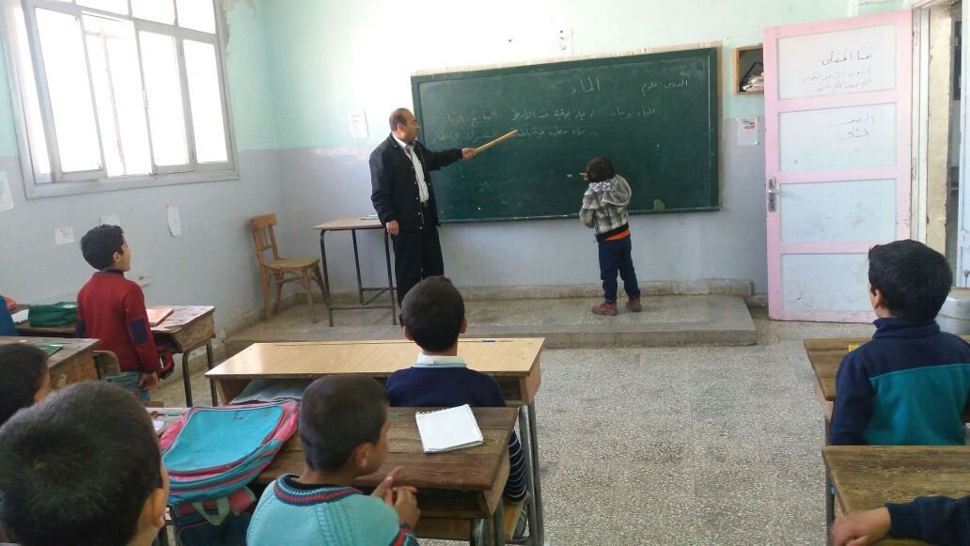

HMG independent monitoring programme

Report for Syria Conflict, Stability and Security Fund (CSSF) – Improving Human Security and Building Peace Capital

Syria

Reporting period – First Monitoring Round – SRM026



Cover photo: Data collection session in Dabeq School, A’zaz District © IMPACT, 2017

About IMPACT
IMPACT Initiatives (IMPACT) is a leading Geneva-based think-and-do-tank. The organization implements assessment, monitoring & evaluation and organisational capacity-building programmes in direct partnership with aid actors or through its inter-agency initiatives, REACH and AGORA. Headquartered in Geneva, IMPACT has an established field presence in over 19 countries. IMPACT’s team is composed of over 400 staff, including 100 full-time international experts, as well as a roster of consultants, who are currently implementing over 50 programmes across Africa, Middle East and North Africa, Central and South-East Asia, Eastern Europe, and the Caribbean.
Table of Contents

Introduction and Background 4
Presentation of the project monitored 4
Methodology 5
Challenges and Limitations 9
Findings 10
Key Findings 10
Findings by Research Question 11
Concluding Remarks 15
Annex 1. Table of the number of SRM paid staff in 23 schools monitored by IMPACT 16
Annex 2. Database of data collected in schools overlapping with ASI 18

Introduction and Background
Upon request from Her Majesty’s Government (HMG) of the United Kingdom of Great Britain and Northern Ireland (UK), IMPACT Initiatives (also referred to as IMPACT) has monitored the HMG-funded project “School support to Akhtarin Education Assembly” (also referred to as SRM026) implemented by Adam Smith International (also referred to as ASI or the Implementing Partner). The project is conducted under the Stabilisation Response Mechanism (hereby referred to as SRM), and aims to assist the moderate opposition’s Education Assembly (EA) in the Akhtarin Sub-District (Aleppo Governorate) in being able to conduct its activities. Mostly, SRM026 supported the EA – apparatus of the Syrian Interim Government’s Ministry of Education in supporting schools at a local level – through, inter alia, the provision of stipends to school staff in 52 schools in the Akhtarin Sub-District.
The purpose of this monitoring was to independently collect and analyse data to verify if the following project outputs had been achieved:
- stipend delivery to school staff (teachers, administrative staff, headmasters and janitors);
- stipend delivery to Akhtarin Education Assembly staff (director and project coordinators), and;
- budget disbursement to the Akhtarin Education Assembly for the purchase of pre-defined office equipment.
This monitoring activity also sought to verify potential deviations in output delivery and give direct beneficiaries (school and Akhtarin Education Assembly staff) an opportunity to provide feedback on the intervention. Based on the received feedback, the data collected can be used to identify potential areas that require re-adjustment within the project.
Monitoring exercises in Syria are challenging due to the highly volatile context and the unstable security environment. The general lack of information, notably concerning population figures, does not allow for representative sampling to be implemented. Therefore contact between field teams and the monitors has to be organised and coordinated by the implementing partner (IP) in order to guarantee a safe environment where participants feel secure and comfortable to share information that supports the monitoring evidence.

Presentation of the project monitored
SRM026 – School support to Akhtarin Education Assembly
Selection criteria: Value greater than 100,000 USD
Since August 2016, Operation Euphrates Shield, led by the Turkish government with Turkey-aligned Syrian opposition groups, has retaken control over 1800 km2 of northern Aleppo Governorate, Syria. A needs assessments conducted by the Aleppo Provincial Council (APC) Stabilisation Committee (SC), with SRM support, identified education rehabilitation as a priority need to help communities recover from Islamic State of Iraq and the Levant (ISIL) occupation.
According to the assessments conducted by the SC and supported by SRM, many schools lacked chairs, tables and heating causing some students to sit on the floor, covered with blankets to protect them from the cold. In addition, teachers have worked on a voluntary basis at the beginning of the academic year, hoping to be added to the payroll list of the Education Directorate (ED).
Under the jurisdiction of the Syrian Interim Government’s Ministry of Education, the education system in moderate opposition-held areas is administered by the Education Directorate (ED) at the Governorate level with the support of the Education Assembly (a sub-unit of the Education Directorate) at the Sub-District level. In partnership with the Education Assembly of the Akhtarin Sub-District, the SRM026 project aimed to address (potential) shortcomings resulting from the missing equipment and teachers working on a voluntary basis through education rehabilitation in 52 schools in Akhtarin Sub-District (A’zaz District, Aleppo Governorate). This was done through the following activities:
- Equipment provision to schools (furniture; teacher and student kits);
- Provision of stipends for three months (starting January 2017) to school staff: 323 teachers; 20 headmasters, 17 school administration staff; and 41 janitors;
- Provision of budget to the Akhtarin Education Assembly for purchasing office equipment;
- Provision of stipends for two months to Akhtarin Education Assembly staff: 1 director and 4 project coordinators.
To note, at the time of the monitoring exercise activity number 1 was on hold due to delays in delivery. For this reason, equipment provision to schools (furniture and teacher and student kits) was not included in this monitoring activity.

Methodology
This IMPACT monitoring exercise was designed in cooperation with HMG and the ASI team to verify if goods and stipends funded by HMG and implemented by ASI were delivered as planned. In addition, this TPM intervention helped to obtain beneficiary feedback on the budget provision for equipment purchase and stipend delivery. Research questions adressed as well as indicators assessed and data colletion methods used can be found in Table 1.
Table 1. Research questions, corresponding indicators and means of verifications
Sampling strategy
Due to the limited accessibility of areas covered by the project, data collection for this monitoring excercise was designed to be complementary to internal monitoring activities conducted by ASI. Therefore, ASI monitored over 20% (11) and IMPACT monitored over 30% (17) of the 52 schools supported by SRM026, covering over 50% of the schools targeted by the project. In addition to these 17 schools, IMPACT monitored six schools also monitored by ASI with the purpose of triangulating obtained results for these overlapping schools, covering a total of 23 schools. In order to prevent sampling biases, the 17 schools exclusively monitored by IMPACT were randomly selected from the list of schools not covered by ASI using an ArcGIS sampling tool. This report relates exclusively to data collected by IMPACT. Data collected in schools overlapping with ASI, to be used for findings triangulation, can be found in Annex 2.
Geographic coverage and timeframe
The monitoring exercise consisted of two Monitoring Rounds in Northern Syria that covered a total of 22 communities in the Akhtarin Sub-District (Aleppo Governorate).
Map 1. Map of monitoring geographical scope
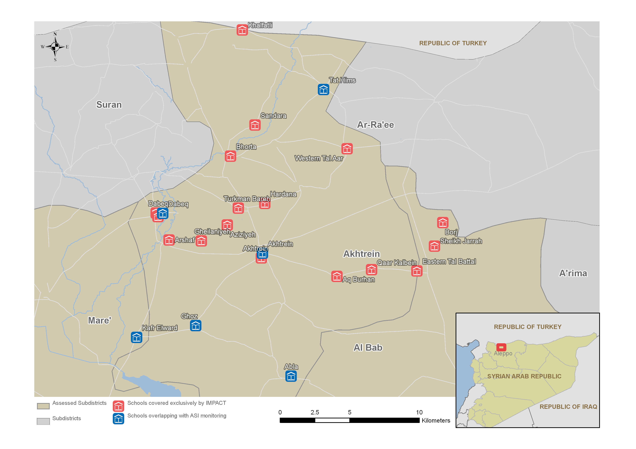
Monitoring Round 1 (MR1) was conducted from 29 March to 5 April 2017. During MR1, IMPACT field teams visited the Akhtarin Education Assembly to verify whether office items listed in project documents had been purchased by the Assembly with funds provided by SRM026 and if the five Assembly staff had received salaries as planned. The revised project budget document shared by ASI was used as a reference for cross-checking and analysing data collected.
Also during MR1, IMPACT field teams visited 23 schools to verify whether school staff had received two months of stipends. Data collected in schools were cross-checked with a payroll sheet signed by school staff after each monthly salary had been received. A total of 123 KIIs were conducted with school and Akhtarin Education Assembly staff, and two DOs were implemented in the Assembly (see Table 2 for more detailed information on MR1).
Table 2. Monitoring activities in Monitoring Round 1 (MR1)
Date | Location(s) | Monitoring Activity | Nb. of staff interviewed
Monitoring Round 1: 6 monitoring days
29-03-17 | Dabeq, Akhtarin | 36 KII | teachers: 20  headmasters: 6  administrative staff: 4  janitors: 6
30-03-17 | Akhtarin (Education Assembly) | 5 KII and 1 DO | Education Assembly director: 1  Education Assembly project coordinators: 4
02-04-17 | Abla, Ghoz, Arshaf, Turkman Bareh, Gheilaniyeh | 31 KII | teachers: 19  headmasters: 5  administrative staff: 2  janitors: 5
03-04-17 | Western Tal Aar, Bhorta, Sandara, Khalfatli, Tat Hims | 25 KII | teachers: 19  headmasters: 2  administrative staff: 1  janitors: 3
04-04-17 | Eastern Tal Battal, Sheikh Jarrah, Aq Burhan, Borj | 7 KII | teachers: 7
05-04-17 | Aziziyeh, Kafr Elward, Qaar Kalbein, Hardana, Akhtrein (Education Assembly), Eastern Tal Battal | 19 KII and 1 DO | teachers: 14  headmasters: 2  janitors: 2  Education Assembly director: 1

Monitoring Round 2 (MR2) was conducted from 13 to 17 May 2017, and designed to verify if school staff had been paid the 3rd month stipend, as stipend delivery of the 3rd month had not yet been completed when MR1 was finalized. A total of 116 KIIs were conducted during MR2 (see Table 3 for more detailed information on MR2). Overall, 239 interviews were conducted throughout the two rounds of data collection, out of which 233 interviews with 159 school staff and six interviews with five staff from the Akhtarin Education Assembly (see Annex 1 for more detailed information on the number of staff interviewed per school).
Table 3. Monitoring activities in Monitoring Round 2 (MR2)
Date | Location(s) | Monitoring Activity | Nb. of staff interviewed
Monitoring Round 2: 5 monitoring days
13-05-17 | Akhtarin, Arshaf, Aziziyeh, Gheilaniyeh | 35 KII | teachers: 22  headmasters: 6  administrative staff: 2  janitors: 5
14-05-17 | Dabeq | 21 KII | teachers: 13  headmasters: 3  administrative staff: 2  janitors: 3
15-05-17 | Bhorta, Mazret Shahin, Qaar Kalbein, Hardana, Sheikh Jarrah, Western Tal Aar | 19 KII | teachers: 16  headmasters: 1  janitors: 2
16-05-17 | Abla, AQ Burhan, Borj, Ghoz, Kafr Elward | 17 KII | teachers: 13  headmasters: 2  janitors: 2
17-05-17 | Eastern Tal Battal, Khalfatli, Sandara, Tat Hims , Turkman Bareh | 24 KII | teachers: 15  headmasters: 4  administrative staff: 2  janitors: 3

Challenges and Limitations
During the implementation of the monitoring, IMPACT field teams experienced some challenges related to remote management and the conflict in Syria:
- Early 2017 saw highly intensified fighting throughout northern Syria. The volatile security situation in SRM026 project locations during the monitoring activities resulted in various changes in the areas accessible to IMPACT field teams. This resulted in one of the randomly selected schools (Qurret Qawaqez) becoming inaccessible to IMPACT monitors due to fighting and related security concerns. This school was later replaced by an accessible school not visited by SRM (Primary of Qabtan). IMPACT informed the IP of this change and modified the list of monitored schools outlined in the monitoring protocol accordingly. As a consequence, overall monitoring results only include limited information on schools located in areas where the security situation was volatile when the monitoring activities were conducted.
- On some occasions, the planning of monitoring visits was also challenged by the delays in the disbursement of budget funds by ASI to the Akhtarin Education Assembly. During IMPACT’s first monitoring visit to the Akhtarin Education Assembly, the IMPACT monitor was informed that the budget to be used for equipment purchase had not been fully disbursed and thus the equipment purchase had not been completed. The IMPACT monitor returned to the site for a second monitoring visit, reducing the cost efficiency of monitoring activities.
- Monitoring Round 1 was conducted before the completion of the 3rd month’s stipend delivery to school staff. This was due to a misunderstanding on the part of IMPACT teams of the status of SRM026 activities, whereby the delivery of all three months of stipends was thought to have been completed by the time MR1 would be conducted. Consequently, a second round of data collection had to be done to collect information to verify the delivery of the 3rd month’s stipend. This had no implication on the overall findings, but further reduced the cost efficiency of monitoring activities.
- In Syria, schools operate in two shifts (morning and afternoon). Due to the lack of information on school shifts, IMPACT monitors sometimes arrived at schools to discover no one present, being obliged to return to the site at a different time to complete the monitoring exercise. This caused an increase in mobility of IMPACT monitors, traveling sometimes long distances to go from one school to the other, also increasing their exposure to security hazards. To note, IMPACT seeks as much as possible all additional information needed to reduce risks associated with monitoring activities.

Findings

Key Findings
TPM findings indicate that SRM026 expected outputs were mostly achieved. Most items listed in the SRM026 project budget document to be purchased by the Akhtarin Education Assembly with the financial ressources provided by SRM026 had been procured in their pre-defined quantities. Exceptions were the printer, provided cost-free by the Education Directorate, and the heater, for which the budget provided to acquire 2 units was only sufficient to purchase 1 unit. Purchases had been adequately documented with invoices seen by IMPACT monitors. Regarding the cost of items, findings point to an underspending on 12 out of 15 items on the purchase list. The observed underspending resulted in the non-utilisation of 29% of financial resources provided by SRM026, as shown in Figure 1.
Figure 1. Utilisation of financial resources allocated to equipment purchase (percentage out of 8,140 USD)
Overall, the Akhtarin Education Assembly director reported that items purchased by the Assembly with resources provided by SRM026 were adequate to the Assembly’s needs in terms of type and quantity. A dissatisfaction was reported regarding the timeliness of purchase approval and budget disbursement by ASI. This was observed particularly in the case of the following items: heater, generator and projector. Delays in budget disbursement were observed to reduce the utility of items (particularly regarding the heater) and were reported to have reduced the Akhtarin Education Assembly’s purchase capacity. Dissatisfaction was also expressed regarding the quality of some purchased items, specifically the laptops. In addition, dissatisfaction was reported with regard to item delivery. According the the Akhtarin Education Assembly director, a few of the lockers purchased had been damaged in the delivery process and, for this reason, were not being used. Althouhg item delivery falls outside of the responsibility of SRM026 and should not be considered as a shortcoming of the project, incidents occurring during item delivery could potentially affect the project’s effectiveness.
With regard to the stipend delivery component of SRM026, findings confirm that Akhtarin Education Assembly staff had been paid the amount indicated in the project’s revised budget document for a period of two months: 1 director: 190 USD/month, 4 project coordinators: 150 USD/month each. Findings also indicate that stipends were delivered to school staff in accordance with the budget salary grid – teachers and administration staff: 100 USD/month each, headmasters: 110 USD/month each and janitors: 80 USD/month each. Findings indicate that 96% of the interviewed staff were paid for the full 3 months covered by SRM026 (January – March 2017). The remaining staff received stipends adjusted to the overall period of employment. The monetary value of the stipend disbursement to the 159 staff interviewed corresponds to an estimated 46,769 USD. This amount is 211 USD less than what would have been disbursed without the adjustments made to employement period. No information was collected on what was done with the remaining 211 USD, nonetheless, remaining stipend of staff not having worked for the three month period was often reported to be used as stipend for additional school staff. This was the case in two out of the four schools in which staff were observed to have been paid less than the full month stipend.
Finally, findings indicate that schools in the area were adversely affected by high staff turnover, insufficient number of staff and the accumulation of work responsibilities, in addition to classroom activities, among few teachers. Furthermore, three schools visited were evidently under the administrative influence of overlapping governing bodies – the Damascus-based government and moderate opposition. In this context, IMPACT enumerators found teachers being paid by the Damascus-based government as well as teachers being paid by the moderate opposition administrative structures (Akhtarin Education Assembly, with support of SRM026) working within the same school.

Findings by Research Question
Research question 1: Are Akhtarin Assembly items purchased as planned?
Type and quantity
Findings show that the Akhtarin Education Assembly has procured items as indicated in the SRM026 revised budget document. All items procured were adequately documented with available invoice and most items had been procured in quantities defined in the SRM026 budget, except for the copier and the heater. The copier – expected to be of a total cost of 1,700 USD – was not available in the area due to lack of supplier and was then provided cost-free to the Akhtarin Education Assembly by the Education Directorate. The heater – expected to cost 50 USD – was purchased at the cost of 96 USD and, for this reason, the EA was only able to procure one heater as opposed to two as initially planned.
Cost
Cross-checks between item invoices and the SRM026 project budget document indicate an underspending of funds allocated for the purchase of 13 out of the 15 items (see Table 4). Items for which no underspending was observed were: the copier (provided cost-free by the ED) and vehicle rental. Regarding the vehicle rental, the amount allocated to this expense was observed to be insufficient to the needs of the EA, as the budget attributed was fully utilised and an additional 75 USD was spent on the car rental under the “miscellaneous” category. No information was collected on what was done with the remaining budget for underspent items as this was not one of the reseach questions in this TPM. Finally, a significant discrepancy was observed between the expected cost and the purchase cost of the heater. This item was acquired at nearly double the cost initially planned.
Table 4. List of purchased items and cost (USD)
Item |  | Quantity planned | Quantity purchased | SRM budget | Total purchase cost | Underspending
 |  |  |  |  |  | Total | % of budget
1 | Printer | 1 | 1 | 250 | 175 | 75 | 30%
2 | Laptop | 5 | 5 | 2,250 | 2,200 | 50 | 2%
3 | Stationery | 3 | 22 | 510 | 325 | 185 | 36%
4 | Copier | 1 | 0 | 1,700 | 0 | 1,700 | 100%
5 | Office chairs | 10 | 10 | 200 | 190 | 10 | 5%
6 | Chairs | 5 | 5 | 350 | 330 | 20 | 6%
7 | Meeting table | 1 | 1 | 175 | 155 | 20 | 11%
8 | Tables | 4 | 4 | 260 | 176 | 84 | 32%
9 | Generator | 1 | 1 | 650 | 535 | 115 | 18%
10 | Locker | 3 | 3 | 195 | 168 | 27 | 14%
11 | Internet device | 1 | 1 | 250 | 235 | 15 | 6%
12 | Heater | 2 | 1 | 100 | 96 | 4 | 4%
13 | Projector | 1 | 1 | 450 | 448 | 2 | 0%
14 | Miscellaneous | (lump sum) | (lump sum) | 300 | 275 | 25 | 8%
15 | Vehicle rental | (lump sum) | (lump sum) | 500 | 500 | 0 | 0%
Total: |  | - |  | 8,140 | 5,808 | 2,332 | 29%

Research question 2: Was the process (disbursement of budget funds and item purchase) adequate to Akhtarin Education Assembly's need?
Satisfaction regarding type, quantity and quality
The Akhtarin Assembly director reported to IMPACT field monitor that items purchased were overall adequate in terms of type and quantity. Concerning the quality of the equipment, the director expressed discontentment with three HP laptops purchased at a cost of 400 USD each with the initial budget, alleging that the amount of 450 USD allocated for this purchase was insufficient to buy an item of higher quality. Two additional Dell laptops were purchased with the amended budget at a cost of 500 USD each, about which no complaints were made.
Satisfaction regarding budget disbursement and item purchase
Dissatisfaction was observed with regard to the budget disbursement for items purchase, due to the lack of timeliness on the part of the SRM026 team. This was due to the delays in the approval of item purchase and disbursement of funds by ASI to the Akhtarin Education Assembly to purchase the following listed items: heater, generator and projector. Findings revealed that the generator, to be used as a power source, was the last item to be procured by the Akhtarin Education Assembly. Consequently, Akhtarin Education Assembly staff was not able to use items that required electricity, such as the printer, until the arrival of the generator. Findings also indicate that this lack of timeliness in purchase approval and disbursement of funds also affected the utility of the items purchased. This was the case of the heater, delivered after the end of the winter season due to delays in purchase approval and disbursement of funds.
Regarding the timeliness of item delivery, the Akhtarin Assembly director indicated that the long time gap between the definition of the list of items to be procured and the final approval of the purchase resulted in the variation of prices due to inflation in conflict affected areas. As a consequence, the Akhtarin Education Assembly’s purchasing power with the available budget was reportedly reduced, and only one heater was acquired as opposed to two as initially planned.
Finally, with regard to the delivery of purchased items, the Ahktarin Education Assembly director reported that a few of the lockers purchased had been damaged in the delivery process and, for this reason, were not being used. No indication was given in terms of the total number or proportion of damaged items. Although item delivery falls outside of the responsibility of SRM026 and should therefore not be considered as a shortcoming of the project, incidents occurring during item delivery could potentially affect the project’s effectiveness.

Research question 3: Were Akhtarin Education Assembly staff paid as planned?
Akhtarin Education Assembly staff stipend delivery
IMPACT field teams interviewed all five Akhtarin Education Assembly staff who have received stipends by the SRM026 project: one director and four coordinators. Findings confirm that all five staff were paid as has been outlined in the project’s amended budget document. The Akhtarin Education Assembly director reported having received 380 USD for a period of two months (190 USD/month), and the four coordinators confirmed having been paid a total of 300 USD each for a two months period (150 USD/month).
Research question 4: Were school staff paid adequately?
Akhtarin school staff stipend delivery
This indicator was informed through KIIs conducted with staff in schools covered by the project, later cross-checked with a payroll sheet signed by paid school staff provided to IMPACT by ASI. In total, SRM026 planned to deliver stipends to 401 staff of schools within the Akhtarin Sub-District, out of which 323 teachers, 20 headmasters, 17 administration staff and 41 janitors. A total of 279 of the 401 staff supported by SRM026 were listed within the 23 schools IMPACT monitored. Throughout the two monitoring rounds, IMPACT field team interviewed 159 staff working within these 23 schools: 114 teachers, 16 headmasters, 9 administration staff and 20 janitors. Interviewees represent 57% of staff being supported by SRM026 within the 23 visited schools and 40% of the total staff being supported by SRM026.
Findings indicate that three months of stipends, in their pre-determined amounts, were delivered to approximately 96% of interviewed staff. The remaining 4% not paid for the full three-month period were:
- 2 janitors: In Ghoz School the janitor included in the SRM026 list only worked during half of the month of March, thus receiving the equivalent of half a month of stipend (40 USD). This janitor was said to have been replaced by someone who received the remaining stipend.
- 1 headmaster: In Dabeq School one headmaster reported having been paid 99 USD for the month of March, against the 110 USD due to non-paid leave.
- 4 teachers: In the Hardana School, one teacher worked and received a stipend during the months of January and February, after which she left the school. This teacher was replaced by another teacher who was paid the remaining stipend for the month of March. In Borj School and in Western Tal Aar School, 2 teachers started work in mid-February and mid-January respectively, and received stipends accordingly.
Findings indicate that the stipends paid to the 159 school staff interviewed resulted in a total spending of 46,769 USD, as shown in Table 5. Had all 159 staff been paid the full 3 months amount, stipend disbursement would have amounted to 46,980 USD. No information was collected on what was done with the remaining 211 USD as this was not within the objectives of this monitoring exercise. Nonetheless, remaining stipend allocation of staff not having worked for the three month period was reported to be used as stipend for additional school staff in two out of the four schools in which this was observed, as mentioned above.
Table 5. Reserved salary and estimated budget disbursement for interviewed staff
Position | # Interviewed staff | Reserved salary (USD/month) | Expected cost (USD) | Cost of staff receiving 3 months (USD) | Cost of staff receiving less than 3 months (USD) | Total cost (USD)
Administration staff | 9 | 100 | 2,700 | 2,700 | 0 | 2,700
Headmaster | 16 | 110 | 5,280 | 4,950 | 319 | 5,269
Janitor | 20 | 80 | 4,800 | 4,560 | 240 | 4,800
Teacher | 114 | 100 | 34,200 | 33,300 | 700 | 34,000
Total | 159 | - | 46,980 | 45,510 | 1,259 | 46,769

Potential diversion of stipends
Only one potential diversion incident was observed out of all interviews conducted during the two Monitoring Rounds. The potential diversion was witnessed in the Gheilaniyeh School, in which a teacher having signed the payroll sheet confirming reception of 3 months of salary was not found in this school during IMPACT’s monitoring visit and key informants present in the school during the monitoring visit reported that this teacher had not been in the school during those months. However, given the turnover of staff observed in other schools, this may be due to the transfer of teachers between schools.
Staff instability observed at school level
General staff instability was observed in schools monitored, namely: high staff turnover, insufficient staffing and accumulation of work responsibilities, beyond classroom activities, among few teachers. In addition, findings also indicate that staff paid by the Damascus-based government and staff paid by the moderate opposition (with the support of SRM026) were sometimes working together within the same school.
Findings point to an elevated turnover in school staff, frequently transferred from one school to another. According to unstructured data obtained from key informants, this is due to the elevated mobility observed in the population in that area and to the volatile security situation. Staff turnover was observed in the Eastern Tal Battal School, where two staff on the SRM staff list (one teacher and one janitor) were not found on the school premises at the time of the monitoring visit. Two other staff present at the time informed IMPACT monitors that they had been transferred to a different school. Those two staff present in the school during that visit (headmaster and teacher) also reported that they had been paid by the Akhtarin Education Assembly, although their names were not present in the payroll sheet. Given that those two staff were found in a school observed to have undergone staff transfers, the elevated turnover could explain why payroll sheet follow-up was not done. Staff turnover was also observed in the case of the AQ Burhan School, where no teachers were found during the monitoring visit. The situation was later clarified during the monitoring visit to the Akhtarin Education Assembly. In that case, the Akhtarin Education Assembly director was able to inform IMPACT monitor that that school had been intercepted by an armed group and teachers were since working in an alternative location (village mosque).
Results also indicate that schools operate with few staff, partially due to the limited number of students attending schools. Three of the schools visited had only one staff (mostly a headmaster) working in addition to the teacher. Two other schools operated with no supporting staff (headmaster, administration staff or janitors). In this context, teachers were observed to have been attributed the role of managing school affairs in addition to providing lessons. Finally, IMPACT TPM findings indicate that teachers affiliated to the Damascus-based government were working alongside teachers and staff whose stipends had been covered by the Akhtarin Education Assembly through the SRM026 project. IMPACT was able to observe this in three visited schools: Khalfalti, Western Tal Aar and Eastern Tar Battal.

Concluding Remarks
Overall, findings indicate that SRM026 has successfully achieved most of expected outputs. Both school staff and Akhtarin Education Assembly staff were observed to have received their stipends according to what was indicated in the project’s amended budget document. Findings also indicate that stipends for school staff were adjusted to the overall period of employment of each individual staff, with remaining stipend of staff not having worked for the three month period reported being used to cover the stipend for additional school staff – in two out of the four schools where this was observed.
Findings indicate that all office items had been acquired by the Assembly with the budget provided by SRM026. Except for the heater, the quantity of purchased items corresponded to what had been planned. However, a lack of timeliness was observed with regard to the disbursement of funds by ASI to the Akhtarin Education Assembly for the purchase of listed items. This was observed to reduce item utility and was reported to decrease purchasing power due to inflation in monitored areas, as in the case of the heater. Overall 29% of the disbursed fund was not used (2,332 USD). No information was collected regarding what was done with the remaining budget as this was not within the objectives of the monitoring activity.
Finally, findings indicate that schools in the area were adversely affected by high staff turnover, insufficient number of staff and the accumulation of work responsibilities, in addition to classroom activities, among few teachers. Findings also point to an overlap in areas of administrative control of the Damascus-based government and of the moderate opposition regarding the public services pay system, where some teachers in a school are paid by the Akhtarin Education Assembly whilst others in the same school are paid by the Damascus-based government. No further information was collected on implications of this on schools and school staff.

Annex 1. Table of the number of SRM paid staff in 23 schools monitored by IMPACT
Table 6. Total staff paid by SRM026 in 23 schools monitored by IMPACT and number of staff interviewed per school monitored
Schools and staff position | Total of SRM026 paid staff | # interviews MR1 | # interviews MR2 | # of repeated respondents (MR1 and MR2)
Abd Alkarim Ahmad | 20 | 7 | 7 | 3
Administration staff | 1 | 1 | 0 | 0
Headmaster | 1 | 1 | 1 | 1
Janitor | 3 | 1 | 1 | 1
Teacher | 15 | 4 | 5 | 1
Abdullmajid Mohammad | 26 | 7 | 7 | 2
Administration staff | 2 | 1 | 0 | 0
Headmaster | 1 | 1 | 1 | 1
Janitor | 2 | 1 | 1 | 1
Teacher | 21 | 4 | 5 | 1
Abla | 11 | 6 | 6 | 5
Headmaster | 1 | 1 | 1 | 1
Janitor | 1 | 1 | 1 | 1
Teacher | 9 | 4 | 4 | 3
Akhtrein Females | 36 | 7 | 7 | 2
Administration staff | 4 | 1 | 1 | 1
Headmaster | 1 | 1 | 1 | 1
Janitor | 3 | 1 | 1 | 1
Teacher | 28 | 4 | 4 | 0
AQ Burhan | 4 | 1 | 2 | 1
Janitor | 1 | 1 | 1 | 1
Teacher | 3 | 1 | 1 | 1
Arshaf | 24 | 7 | 7 | 4
Administration staff | 1 | 1 | 1 | 1
Headmaster | 1 | 1 | 1 | 1
Janitor | 2 | 1 | 1 | 1
Teacher | 20 | 4 | 4 | 1
Aziziyeh | 15 | 6 | 7 | 4
Headmaster | 1 | 1 | 1 | 1
Janitor | 2 | 2 | 2 | 2
Teacher | 12 | 4 | 5 | 3
Bhorta | 9 | 6 | 6 | 6
Headmaster | 1 | 0 | 1 | 0
Janitor | 1 | 1 | 1 | 1
Teacher | 7 | 4 | 4 | 4
Borj | 3 | 3 | 2 | 2
Teacher | 3 | 3 | 2 | 2
Eastern Tal Battal | 2 | 2 | 2 | 2
Headmaster | 1 | 1 | 1 | 1
Janitor | 1 | 1 | 1 | 0
Teacher (teacher listed in SRM documents under a different school - Aq Burhan) | 0 | 1 | 1 | 1
Gheilaniyeh | 12 | 5 | 7 | 5
Headmaster | 1 | 1 | 1 | 1
Janitor | 2 | 1 | 1 | 0
Teacher | 9 | 3 | 5 | 3
Ghoz | 9 | 6 | 5 | 5
Headmaster | 1 | 0 | 1 | 0
Janitor | 1 | 1 | 1 | 1
Teacher | 7 | 4 | 4 | 4
Hardana | 3 | 2 | 3 | 2
Teacher | 3 | 2 | 3 | 2
Kafr Elward | 2 | 2 | 2 | 2
Teacher | 2 | 2 | 2 | 2
Khalfatli | 2 | 2 | 2 | 2
Teacher | 2 | 2 | 2 | 2
Preparatory of Dabeq | 14 | 7 | 7 | 4
Administration staff | 2 | 1 | 2 | 1
Headmaster | 1 | 1 | 1 | 0
Janitor | 2 | 1 | 1 | 1
Teacher | 9 | 4 | 3 | 1
Qaar Kalbein | 7 | 6 | 5 | 4
Janitor | 1 | 0 | 0 | 0
Teacher | 6 | 5 | 4 | 3
Sandara | 8 | 6 | 6 | 5
Headmaster | 1 | 1 | 1 | 1
Janitor | 1 | 1 | 0 | 0
Teacher | 6 | 4 | 4 | 3
Sheikh Jarrah | 3 | 3 | 3 | 3
Teacher | 3 | 3 | 3 | 3
Southern Akhtrein | 24 | 8 | 7 | 3
Headmaster | 2 | 1 | 1 | 1
Janitor | 2 | 1 | 1 | 1
Teacher | 20 | 4 | 4 | 0
Tat Hims | 14 | 7 | 7 | 3
Administration staff | 2 | 1 | 1 | 0
Headmaster | 1 | 1 | 1 | 1
Janitor | 1 | 2 | 1 | 1
Teacher | 10 | 5 | 4 | 2
Turkman Bareh | 26 | 7 | 7 | 4
Administration staff | 2 | 1 | 1 | 1
Headmaster | 1 | 1 | 1 | 1
Janitor | 2 | 1 | 1 | 1
Teacher | 21 | 4 | 4 | 1
Western Tal Aar | 5 | 4 | 2 | 1
Teacher | 5 | 4 | 2 | 1
Grand Total | 279 | 117 | 116 | 74

Annex 2. Database of data collected in schools overlapping with ASI

The purpose of SRM is to plan and implement short-term stabilisation measures in moderate-opposition held Syrian sub-districts no longer under the control of the Islamic State of Iraq and the Levant (ISIL) or the Damascus-based government. SRM interventions aim to prevent security and services vacuum through a vast range of activities, including inter alia stipend provision, operational budgets, equipment supply, capacity building and/or technical assistance.
Located 38 km northeast of Aleppo city and 13 km northeast of Marea town.
Established in December 2015, the Stabilisation Committee of the Aleppo Province Council has the role of mapping areas across the province of Aleppo, conducting assessments on stabilisation needs and coordinating with programmes and donors to secure funds for the stabilisation response.
This information was provided by SRM026 project proposal. No additional clarification is given as to if and when this would happen.
Responsible for curricula, stipends and school management.
Established on 25 January 2017 by the Syrian Interim Government (SIG) Ministry of Education.
Located 38 km northeast of Aleppo city and 13 km northeast of Marea town.
This activity was under the responsibility of the Akhtarin Education Assembly. The total number of school staff supported by SRM026 used as reference for the analysis was 401. This number differs from what is indicated in the project proposal (389 school staff), nonetheless refers to the revised staff list provided to IMPACT assessment team by SRM026 project manager on 22 March 2017, prior to the data collected.
The complete list of items to be purchased by the Akhtarin Education Assembly can be seen at Table 4.
In total, ASI and IMPACT monitoring activities covered 28 out of the 52 schools supported by SRM026 – 54% of total number of supported schools.
Overlapping schools were: Abd Alkarim Ahmad (Dabeq village), Abla (Abla village), Akhtarin Females (Akhtarin village), Ghoz (Ghoz village), Kafr Elward (Kafr Elward village) and Tat Hims (Tat Hims village).
Geographic information system (GIS) programme for working with maps and geographic information.
The revised budget reflected final revised agreement signed by SRM and the Akhtarin Education Assembly, outlining changes and additions to be done to the SRM026 project (Accountable Cooperation Agreement n. 08/2017 – Amendment 1).
MR1 initially planned to verify the delivery of all three months of stipend. However, given that the 3rd month of stipend had not yet been delivered at the time of data collection, this was narrowed to the verification of two months’ worth of stipend delivery.
43 staff interviewed exclusively in MR1, 42 exclusively in MR2 and 74 interviewed both in MR1 and MR2.
The shift in which schools operate in is often subject to change in response to this security situation, as observed during other monitoring activities conducted by IMPACT for HMG as for example the monitoring of Taallum Initiative project activities in Aleppo and Idlib Governorates.
Photos of invoices are available and will be shared by IMPACT upon request.
According to the revised budget document, a total of two months were said to be covered by the project as opposed to three months as was indicated in the initial project proposal.
The copier excluded, the average underspending was per item was 12% of the resources allocated.
No information was available, either within project documents or within EA purchase receipts, as to what the unit of stationery was. Thus no conclusion can be drawn as to whether this item was purchased in the quantity planned or not.
Miscellaneous lump sum was spent with a stove, a gas bottle and saple goods as well as additionnal vehicle rental costs.
Analysis was done using as reference the amended budget document (most updated document provided by IP) where a total of two months were said to be covered by the project as opposed to three months as was indicated in the project proposal.
The following calculations were done per school staff not paid the full-month stipend: headmaster: (2 x 110) + 99; janitors: [(2 x 80) + 40] + 40; teachers: (3 x 100) + [50 + (2 x 100)] + (50 + 100).
The data collection tool was not designed in a way for this information to be systematically collected meaning that other schools visited might also be operating in a similar way.

