TECHNICAL PROTOCOL

FOR

Standardized Monitoring and Assessment of Relief and Transitions (SMART) Survey in Maiwut County, Upper Nile State, South Sudan

Submitted by

REACH Initiative In Partnership with Relief International


March 2026
Contents
1.0 BACKGROUND 4
1.1 Introduction 4
1.2 South Sudan acute malnutrition situation for first projection period (Oct 2025 - Mar 2026) 5
1.3 South Sudan acute food insecurity situation for projection period (Dec 2025 - Mar 2026). 6
1.4 Rationale/justification of the survey. 7
1.5 Survey Objectives 8
1.6 Survey Areas 9
1.7 Survey time 9
2.0 METHODOLOGY 10
2.1 Survey Design 10
2.2 Study Population 10
2.3 Sample Size Estimation 11
2.3.1 Anthropometric Sample Size 11
2.3.2 Mortality Sample Size 12
2.3.3 Number of Clusters 13
2.4 Sampling Procedure: Selection of Clusters 13
2.5 Sampling Procedure: Selection of Households and Children 14
2.6 Survey Teams, Training, Data Collection and Data Management 14
2.7 Data Quality 15
2.8 Questionnaire 15
2.9 Data to be Collected 15
2.10 Data Analysis 16
2.11 Ethical Considerations 17
Annex 1. Survey Plan 18
Annex 2. Cluster control form 19
Annex 3. HOUSEHOLD LISTING AND ANTHROPOMETRY 20
Annex 4. FOOD CONSUMPTION LISTING 21
Annex 5. IYCF – 24 hours diet recall form 22

1.0 BACKGROUND

1.1 Introduction
The Republic of South Sudan became the world’s youngest nation and Africa’s 54th country on 9 July 2011. Since independence, the country has faced significant challenges, including outbreaks of civil war in 2013 and 2016, persistent subnational violence, and ongoing political contestation. These dynamics, compounded by weak public resource management, have constrained development and driven escalating humanitarian needs. The signing of the Revitalized Agreement on the Resolution of the Conflict in the Republic of South Sudan (R-ARCSS) in September 2018 and the formation of a Transitional Government of National Unity in February 2020 marked important steps toward stability. The transitional period has since been extended to February 2027, allowing additional time to implement the provisions of the peace agreement and prepare for national elections. Despite this progress, the peace process continues to face significant challenges, including the unification of armed forces and the drafting of a permanent constitution.

South Sudan remains in a severe humanitarian crisis driven by conflict and insecurity, high living costs, intercommunal violence, and widespread food insecurity. These factors have severely disrupted livelihoods and limited access to essential services. The ongoing influx of returnees and refugees from Sudan is further exacerbating the situation, causing widespread displacement, disruption of livelihoods, and chronically high levels of acute food insecurity and malnutrition. The Peace deal signed in September 2018 resulted in improved security and increased access to affected populations for humanitarian assistance, and an increase in refugees and Internally Displaced Persons (IDPs) returning to their communities. However, as of July 2023, there remained an estimated 2.4 million refugees from South Sudan residing in neighboring countries (Uganda, Sudan, Ethiopia, Kenya, DRC).

The latest IPC analysis for South Sudan (October 2025) revealed a continually severe health and nutrition situation in South Sudan. The analysis estimated 5.97 million people (42 percent of the total population analyzed) were experiencing high levels of acute food insecurity (IPC Phase 3 or above) between September and November 2025, with 1.3 million people facing IPC Phase 4 (Emergency). An estimated 28,000 people were classified in IPC Phase 5 (Catastrophe), including 17,000 people in Luakpiny/ Nasir (Upper Nile) and 11,000 people in Fangak (Jonglei). The most food insecure states with the highest number of people facing IPC Phase 3 or above (Crisis or worse) between December 2025 and March 2026 will include Upper Nile (57%) and Unity (56%). By June 2026, 2.11 million children in South Sudan are expected to suffer from acute malnutrition. Of those, 670,000 will likely face Severe Acute Malnutrition (SAM). The very high prevalence of acute malnutrition remains a public health concern.

Maiwut County is located in Upper Nile State, is one of 76 counties out of 80 to remain in critical (phase 4) in IPC AMN classification. Maiwut County borders Luakpiny/Nasir County to the west and Longochuk County to the north. It also shares a long eastern and southern border with Ethiopia. A primary road links Maiwut town southeast through Pagak to Gambela, Ethiopia, and northwest to Melut via Mathiang and Guel-Guk. During the 2024 rainy season and the 2025 dry season, this road was assessed as impassable, significantly constraining ground access. In addition, the Jikou/Jekow (Baro) River runs along Maiwut’s southern border at Turuu and serves as a key route for riverine transport, ultimately flowing into the Sobat River. The UNHASS recognized heli-landing sites and airstrips is in Maiwut town and other landing sites are Jikou/jekow (Pilual), Pagak, and Urieng. Maiwut County lies within the Northeastern maize, cattle, and fishing livelihood zone (FEWS NET, 2018) and extends along the eastern floodplain of the White Nile, characterized by grasslands, forests, and swampy areas. Livelihoods are predominantly agro-pastoral, with earlier assessments indicating that around 70% of households were engaged in farming (FAO/WFP, 2019); however, more recent FAO/WFP data show a decline to approximately 65% of households, alongside persistently low gross cereal yields of about 0.5 metric tonnes per hectare in both 2021 and 2022 (FAO/WFP, 2022; FAO/WFP, 2023). Key crops include maize, sorghum, cowpeas, pumpkins, and okra, while livestock production mainly involves cattle, goats, and poultry. Agricultural production is entirely rain-fed, with the main harvest occurring in March.

1.2 South Sudan acute malnutrition situation for first projection period (Oct 2025 - Mar 2026)
In the most recent IPC for Acute Malnutrition (IPC-AMN) report, published in November 2025, Maiwut County is classified as IPC AMN Phase 4 (Critical) in the most recent IPC-AMN analysis and was identified as one of the counties requiring updated representative data due to sustained critical levels and the absence of a recent SMART survey.”, based on the data obtained from MUAC, for the analysis period (July-September 2025) as well as for the first (October 2025-March 2026) and second (April-June 2026) projections periods. The major drivers of acute malnutrition include high disease prevalence, poor sanitation, sub-optimal infant and young child feeding practices, and food insecurity.
Figure 1 - South Sudan acute malnutrition situation for first projection period (Oct 2025 - Mar 2026). source, ipcinfo.org
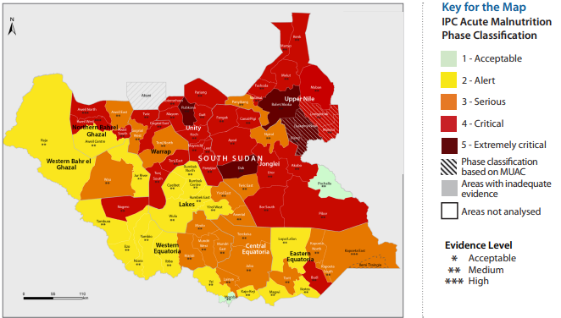

1.3 South Sudan acute food insecurity situation for projection period (Dec 2025 - Mar 2026).
South Sudan's severe food insecurity and malnutrition condition is deteriorating. The situation is becoming worse as a result of the influx of refugees and returnees fleeing the conflict in neighboring Sudan. Large-scale violence is also driving considerable internal displacement, most recently in northern Jonglei State. The arrival of displaced persons places additional pressure on host communities’ resilience to shocks. An estimated 5.97 million people (42 percent of the population analyzed) were classed in IPC Phase 3 or above (Crisis or worse) between September and November 2025. In the first projection period (December 2025 to March 2026), 5.86 million people (41 percent of the population analysed) will likely experience IPC Phase 3 or above (Crisis or worse). An estimated 1.30 million people (9 percent of the analysed population) in South Sudan are classified in IPC AFI Phase 4 (Emergency) in this period, while approximately 28,000 people are facing IPC AFI Phase 5 (Catastrophe) conditions. Nine counties, primarily in Jonglei and Upper Nile States, are classified in Emergency. In addition, 58 counties are in IPC AFI Phase 3 (Crisis) including Maiwut County and 12 counties in Phase 2 (Stressed). The most severely affected states, Upper Nile (57 percent), Unity (53 percent), and Jonglei (50 percent), account for more than half of the population facing high levels of acute food insecurity nationwide.
Figure 2 - South Sudan acute food insecurity situation for projection period (Dec 2025 - Mar 2026). source, ipcinfo.org
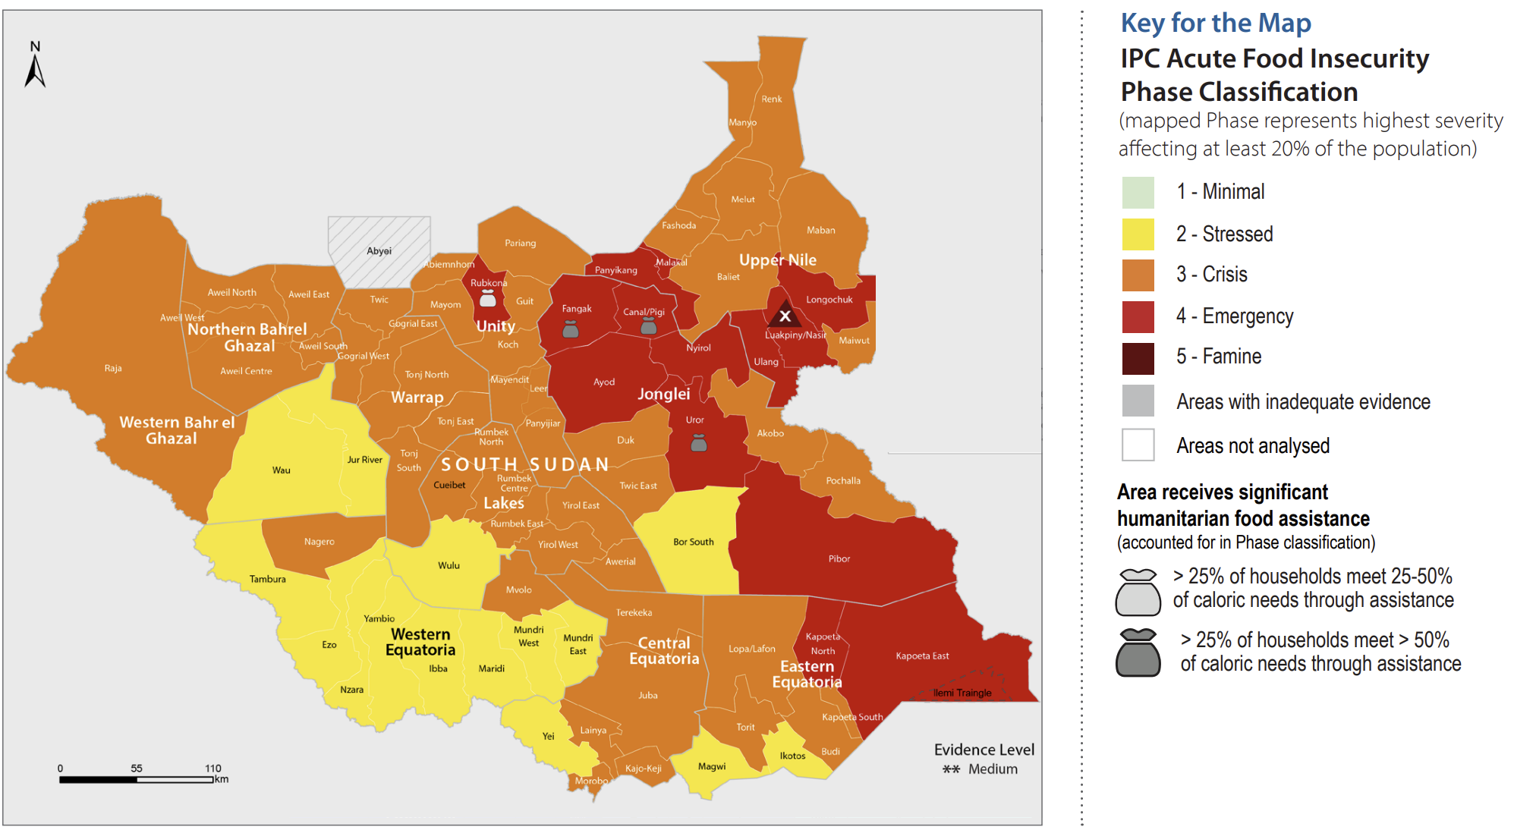

1.4 Rationale/justification of the survey.
There has not been a SMART survey in Maiwut County since 2019. Since then, available information suggests a continuation of critical malnutrition levels. Since the last SMART survey was conducted over 6 years ago (December 2019) by ACF, there have been an influx of Sudanese refugees and South Sudanese returnees from Sudan and increase internally displaced persons (IDP) into Maiwut County, yet limited data on health and nutrition have been gathered. Furthermore, during the latest IPC Acute Malnutrition (AMN) analysis workshop (October 2025), Maiwut was classified in IPC AMN Phase 4 in the current and projection periods. This was based on a MUAC screening exercise conducted at the peak of the 2025 lean season with the prevalence of GAM rate on MUAC was 7.80% (2.9-19.4, 95% CI) . In 2026, there is a need and an opportunity to conduct a SMART survey to determine the current nutrition situation of the population, and to provide robust, updated data on food security and public health-related aggravating factors to inform and guide relevant response in the county.
As there was no SMART survey conducted recently in Maiwut County, for the sake of this technical protocol, the parameters were taken from the neighboring county Luakpiny/Nasir SMART survey conducted in 2022 to calculate the sample size of the survey. Accordingly, the Luakpiny/Nasir SMART survey revealed a Prevalence of GAM rate based on Weight-for-height Z-score of 15.9 % (12.9-19.5 95% CI), which is above the WHO emergency threshold of 15% There has been an increase in population displacement in Luakpiny/Nasir, similar to the situation in Maiwut County. When comparing livelihoods with the neighboring Gambella region in Ethiopia, the SMART+ survey conducted there reported a high GAM prevalence of 17.1% (95% CI: 14.1%–20.7%), which exceeds the WHO emergency threshold of 15%. Most areas in Gambella share similar livelihood patterns with Maiwut County, supporting the relevance of these findings for contextualizing malnutrition risks in Maiwut. This GAM rate was used because the counties have common livelihood activities. Findings from the survey will support planning, targeting and response by Relief International, partners and key stakeholders on issues related to nutrition, health, WASH and FSL within the county.
The nutrition situation in Maiwut County has not been regularly monitored through annual SMART surveys, with the last one conducted in December 2019. In order to fill the information gap on the current nutrition situation in Maiwut County, REACH Initiative and Relief International are planning to conduct a SMART survey from, approximately, March 5th to March 30th of 2026, collecting anthropometric and mortality data, as well as key multi-sectoral indicators – on Food Security and Livelihoods (FSL), Water, Sanitation and Hygiene (WASH), and Health - to better understand the status of Acute Malnutrition (AMN) in Maiwut County, as well as its key drivers.

REACH Initiative, present in South Sudan since 2012, has been conducting needs assessments and providing evidence-based information to inform the humanitarian response in South Sudan. And since 2019, REACH has engaged with the Nutrition Information Working Group (NIWG), participating in the IPC Acute Malnutrition analysis workshops, and providing technical support to nutrition partners for SMART surveys implementation in the country. SMART survey is a methodology widely used in Sub-Saharan Africa to conduct timely nutrition surveys, by governments and humanitarian partners alike, in all types of contexts (emergency, development, displaced populations, etc.). SMART surveys are generally recommended to be conducted twice a year in relation to pre- and post-harvest periods, to accommodate seasonal malnutrition, and can be conducted at the national or regional level, and even on a smaller scale.

Figure 3: Maiwut County Reference Map

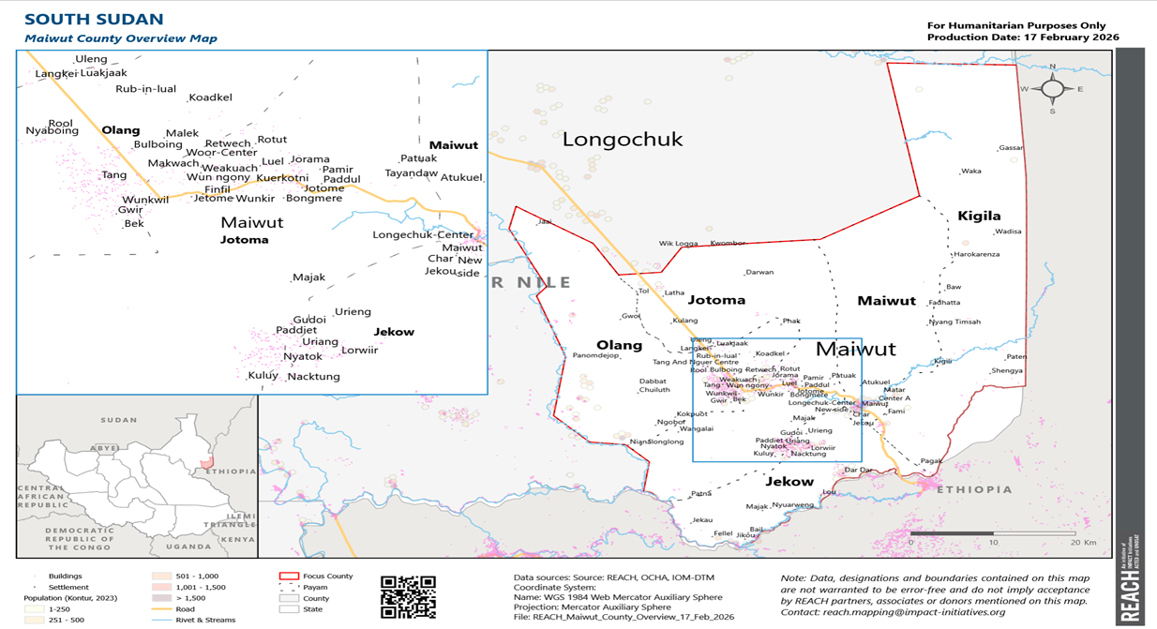

1.5 Survey Objectives
General Objectives
To assess the nutrition situation and retrospective mortality rates amongst the overall population, and to analyse the possible factors contributing to acute malnutrition of the community in Maiwut County. In particular, the following are the specific objectives of the assessment:
Specific Objectives
- To estimate the prevalence of acute malnutrition, stunting and underweight among children (boys and girls) aged 6 – 59 months in Maiwut County.
- To estimate the retrospective Crude Mortality Rate (CMR) for the overall population and Under 5 Mortality Rate (U5MR) Maiwut County.
- To estimate the coverage of various immunizations in Maiwut County including:
  - Vitamin A supplementation (for children 6-59 months)
  - Deworming (for children 12 to 59 months)
  - Measles vaccination coverage among children 9-59 months.
- To assess childhood morbidity and health-seeking behaviors among households with children aged 6-59 months in Maiwut County.
- To assess the nutritional status of women of reproductive age (15-49) in Maiwut County.
- To assess IYCF Practices such as breastfeeding and complementary feeding among mothers who have children under the age of two years in Maiwut County.
- To assess the WASH situation in Maiwut County (Main water source, distance/time to water source, water treatment status, access to soap, access to latrine).
- To assess the food security and livelihoods situation in Maiwut County [Food Consumption Scores (FCS), Household Hunger Scale (HHS), main livelihoods, and Livelihood Coping Strategies (LCS)].
- To formulate practical interventions and recommendations for both emergency and long-term programs of Nutrition actors in Maiwut County.

1.6 Survey Areas
The SMART survey will be implemented across the entire Maiwut County, covering all accessible payams and communities to ensure representative data collection for both anthropometric and mortality indicators.

1.7 Survey time
This survey will be conducted during the post-harvest period (month of March 2026) according to the South Sudan seasonal calendar, a time when households are generally expected to have some produce available. Please refer to the South Sudan seasonal calendar in the image below for further understanding.
Figure 4 - South Sudan seasonal calendar
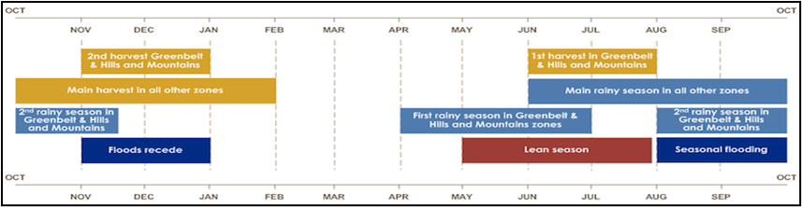

2.0 METHODOLOGY

2.1 Survey Design
The survey will apply cross-sectional study design with a two-stage cluster sampling using the SMART methodology with the clusters being selected using the probability proportional to population size (PPS). Stage one sampling will involve the sampling of the clusters (the smallest geographical units, in our case villages) to be included in the survey while the second stage sampling will involve the selection of the households from the sampled clusters. The survey targets children 6-59 months and households in assessing the nutrition and mortality indicators, respectively.

2.2 Study Population
The target population for this survey will be: 1) Children aged 6 – 59 months for the anthropometric, children aged 0 -23 months for Infant and Young Child Feeding (IYCF) practices, and 2) General population for the Mortality, Food Security and Livelihoods (FSL), Health, and Water, Sanitation and Hygiene (WASH) components, including in this group Pregnant and Lactating women (PLW) to investigate about child health seeking behavior components.
Table 1: Indicators and target population
 | Key Indicators | Target Population
1. | Prevalence of acute malnutrition 2-week retrospective child morbidity & health-seeking behaviour | Children 6 – 59 months
2. | Vitamin A supplementation | Children 6 – 59 months
3. | Measles coverage | Children 9 – 59 months
4. | Deworming | Children 12 – 59 months
5. | Prevalence of PLW acute malnutrition by MUAC | WRA (15 -49 years)
6. | Infant and young child feeding practices | Children 0-23 months
7. | Under-five mortality rate | Children 0-59 months
8. | Crude mortality rate | All people (households)
9. | FSL- HHS, FCS and LCS | All people (households)

2.3 Sample Size Estimation
Sample size calculation for the survey will be based on the expected prevalence of Global Acute Malnutrition (GAM) and Mortality Rate in the survey areas. At the time of protocol development, no recent and representative SMART survey data were available for Maiwut County, the parameters used have been extracted from the previous survey reports conducted by REACH in Luakpiny/Nasir County in 2022, since they have the same domain the upper confident interval will be used for Anthropometric Sampling. In line with SMART methodology guidelines, the most recent and reliable survey data from the same domain were used to inform key population assumptions, a neighboring population with similar characteristics. The Anthropometric and mortality sample sizes have been calculated using Emergency Nutrition Assessment (ENA) software (January 11th, 2020, version) following SMART methodology.

2.3.1 Anthropometric Sample Size
Table 1: Sample Size (Anthropometric)
Parameter | Maiwut County | Justification
Estimated Prevalence (%) | 19.5 | Since there has been no any SMART survey conducted in Maiwut county, The estimated GAM prevalence for Luakpiny/Nasir of 15.9% (12.9 – 19.5 95% CI) which was conducted in 2022 was used for sample size calculation for Maiwut County SMART Survey. This is based on findings from the Luakpiny/Nasir SMART survey, as both counties belong to the same analytical domain and share similar livelihood systems, food security conditions, access to health and nutrition services, and seasonal risk factors. The upper limit 19.5% is used due t0 the 2026 context on conflict and displacement is expected to be much worse compared to 2022. In the absence of recent SMART data for Maiwut County, SMART methodology recommends using the most recent and reliable survey data from the same domain to inform key assumptions.
Desired Precision | 4.5 | According to SMART methodology guideline.
Design Effect | 1.5 | Consistent with SMART survey guidance, a design effect of 1.5 was used to account for clustering and heterogeneity within the Maiwut population, which includes host communities, South Sudanese returnees from Sudan, and internally displaced persons (IDPs) displaced by conflict.
Children to be Included | 486
Average Household Size | 6.5 | As per the Luakpiny/Nasir SMART survey and as well base on the context of South Sudan (NBS) national Baseline Household Survey and VASD.
% children Under-Five | 19 | The 19% of Children under five was considered based on National EPI estimate and VASD
% Non-Respondents | 3 | Anticipated non-response
Households to be Included | 451

2.3.2 Mortality Sample Size
Table 2: Sample Size (Mortality)
Parameter | Maiwut County | Justification
Estimated death rate per 10,000/day | 1.82 | Base on the SMART survey conducted in Luakpiny/Nasir in 2022 by REACH (Maiwut Domain), the point prevalence for CMR was 1.82% (1.28 – 2.59 95% CI). Considering the population composition in Maiwut, which includes South Sudanese returnees from Sudan and conflict-affected internally displaced persons (IDPs), a point prevalence of 1.82% is recommended to account for a potentially higher mortality risk.
Desired Precision | 0.65 | As per the SMART guidelines.
Design Effect | 1.5 | In line with SMART survey methodology, a design effect (DEFF) of 1.5 is recommended to reflect the anticipated population heterogeneity in Maiwut, including host communities, South Sudanese returnees from Sudan, and internally displaced persons (IDPs).
Recall Period | 90 | A default three-month recall period was applied; this will be adjusted once the survey starts.
Population to be Included | 3002
Average Household Size | 6.5 | As per the Luakpiny/Nasir SMART survey and as well base on the context of South Sudan (NBS ^{(ibid)}) national Baseline Household Survey and VASD.
% Non-Respondents | 3 | Anticipated non-response
Households to be Included | 476

The maximum sample size is found to be the Mortality sample size calculation, and this will be considered the final sample size, with 476 households in Maiwut County to be included in the survey.

2.3.3 Number of Clusters
To determine the number of clusters required, the number of households that a team can comfortably survey in a day was estimated using the parameters found in Table 3 below:
Table 3: Number of households a team can sample in a day
Activity | Estimated Time
Departure from Office | 7:30 AM
- Daily morning briefings | 15 min
- Travel to clusters | 50 min
- Introduction and HH list development | 30 min
- Lunch break | 30 min
- Total Time from one HH to another | 5 min
- Travel back to base | 50 min
Total time for HH listing, travelling and breaks (a + b + c + d + f) | 175 min
Arrival back to Base | 5:30 PM
Total available time in a day | 10 hrs (600 minutes)
Available time for work | 600 - 175 minutes= 425 minutes
Time taken to complete one questionnaire | 30 minutes
Total time per household + e | 35 minutes
Note: The above are only estimates based on past experience but will be updated after the pilot survey has been conducted and thus, slight changes may be expected.

Given the above, the number of households that a team can comfortably visit in a day is calculated as follows:
425 (min) / 35 (min) = 12.14 ~ 12 HH/per day
Given the above, the number of clusters per survey area is presented in the table below:
 | Maiwut County
Total number of HH based on sample size calculation | 476
Total number of HH to be assessed per day per team | 12
Clusters Needed | 39.6
Rounded UP | 40

2.4 Sampling Procedure: Selection of Clusters
A two-stage cluster sampling design will be used to sample the survey clusters and households. In the first stage, clusters will be assigned using Probability Proportional to Size (PPS). The sampling frame for the 1st stage sampling will be the list of villages with the population estimates in each of the survey areas. The list of villages will then be entered into ENA for SMART software (version Jan 2020) and clusters assigned using probability proportional to size (PPS).

2.5 Sampling Procedure: Selection of Households and Children
Definition of household for the survey: The second stage sampling involves the selection of 12 households per cluster through a simple random sampling using a random number generator (RNG) installed in the data collection tablets. For this survey, a household (HH) will be defined as a group of people living together, who cook and eat from the same cooking pot. Polygamous families will be defined based on the same, if each wife has her own pot, even if living in the same compound, this will be treated as different households.
Household selection techniques: The standard definition of a HH will be shared with enumerators to guide them in developing the HH listing within the cluster. On arrival in the selected clusters, the team leader will meet with the village elders. The team will introduce themselves, explaining the survey objectives as well as expectations from the elder. Then either of the following two methods will be used for household listing: 1) A verbal listing from one or more community leaders, and, if not possible, then 2) A manual house to house listing. They will each be assigned a number, and the numbers will be selected randomly using the random number generator application in smart phones. Twelve households will be randomly selected from the complete list of HHs. These are the HHs that will be visited by the survey team. The village guide and community leaders will support the teams in updating the list of households.

For clusters/villages with more than 150 HHs segmentation will be used to first select one portion of the cluster that will represent the cluster. Selection of segments will be done using either PPS or simple random sampling, depending on the population sizes of the specific segments. In the selected segment, the process of HH selection will follow the same process done in each cluster for the selection of the 12 HHs. Households will be selected using a Random Number Generator software.

In selected households, all eligible children (aged 6-59 months) will be measured, and the household questionnaire applied. Absent households and households with absent children will be re-visited and information of the outcome recorded on the cluster control form. This form will also be used to record information on absent and non-responding households.

2.6 Survey Teams, Training, Data Collection and Data Management
- Survey Teams: Six teams with four members (1 Team Leader, 1 measurer, 1 assistant, 1 enumerator) in each team will be involved in the execution of the survey. At each cluster, a local guide will be employed to facilitate data collection at the household level. The survey teams will be recruited by REACH with the involvement of the local officials at Maiwut County level. To the extent possible, the team members will be a mix of both male and female persons and will be recruited from the local communities. REACH will supervise the teams with technical support from Relief International organization.
- Training: The survey teams will be trained for five days, with the training planned to start on March 9th, 2026. The training will cover various components including taking anthropometric measurements, sampling of households, data collection tools, digital data collection, data quality checks, and standardization exercise among other themes. The training of the enumerators will be facilitated by SMART certified staff and staff with experience conducting SMART surveys.
- Supervision: The overall management of the survey will be done by REACH Initiative with support from Relief International. Maximum supervision of the survey teams will be ensured to facilitate quality data.
- Data Entry and Management: Data will be collected through REACH tablets using Kobo/ODK. The data collection tools will be programmed and uploaded onto the tablets which will be used by the survey teams. The teams will be uploading the collected data to a central server on a daily basis to allow the Survey Manager to review the data collected each and every day and clean the data and give the feedback every morning to the teams.

NB: Backup manual forms will be carried by each team as a contingency plan in any eventuality that teams face challenges with the SMART phones

2.7 Data Quality
In order to ensure optimal and high data quality, a number of measures will be put in place which includes:
- The survey will be done in accordance with the submitted protocol, and the following will be ensured:
  - Training of survey teams is done using standardised material as recommended by SMART Methodology
  - Undertaking of standardisation test as part of the training; taking appropriate steps thereafter based on the performance of the survey teams
  - Appropriate calibration of survey equipment, during the training and on every morning before proceeding to the field for data collection
  - Plausibility checks will be conducted on a daily basis and inform the daily debriefing sessions which will be conducted every day
- Data will be collected a digital platform, and control checks and skip patterns will be programmed to improve the data quality.
- Anthropometry data will be auto analysed using ENA software anthropometry section. The same software will be used to analyse the mortality data.

2.8 Questionnaire
The survey will adopt the data collection tools which have been developed by the Global SMART Team for both anthropometric and mortality surveys. Other indicators will be collected using the modules in line with current Food Security and Nutrition Monitoring System (FSNMS) questionnaires as much as possible.

2.9 Data to be Collected
- Anthropometry for children aged 6 -59 months
- Age: Will be determined using birth/health cards/records if available and local calendar of events which will be jointly developed by local leaders and survey enumerators.
- Sex: Male or female.
- Weight: Children’s weights will be taken without clothes using mother and child digital weighing scales (SECA scales with precision of 100gm).
- Height/length: Children will be measured using the wooden UNICEF measuring boards (precision of 0.1cm). Children less than 2 years of age will be measured lying down, while those greater than or equal to 2 years of age will be measured standing up.
- Mid-upper arm circumference (MUAC): MUAC measurements will be taken at the mid-point of the left upper arm using both the child and adult MUAC tapes (precision of 0.1cm) for children 6-59 months and for women of reproductive age between 15-49 years of age.
- Bilateral pitting oedema: Will be assessed by the application of normal thumb pressure on both feet for 3 seconds.
- Referral: All children with acute malnutrition and not already enrolled in treatment will be referred using referral forms to existing TSFP and OTP programs in the county.
- Demographics and Mortality: The following information will be collected for all current household members: age in years, sex, whether they were born, or had joined the household during the recall period of 90 days (will be amended in the field). For household members that left during the recall period, data will collected of their age in years, sex, and whether they had joined or born into the household during the recall period. For persons who have died during the recall period, will collect age in years, sex, whether born or joined the household during the recall period, as well as estimated cause and location of death.
- Health Interventions Data for children aged 6 -59 months: Vitamin A supplementation, deworming and measles immunization data will be collected through health cards or recall.
- Morbidity: Two-week retrospective morbidity data will be collected from mothers/caregivers of all children (6-59 months) included in the anthropometric survey.
- Food Security Indicators for the overall population:
  - Food Consumption Scores (FCS): is an indicator of the general quantity and quality of foods being consumed in a household, based on how many days any household members have consumed 9 distinct food groups within a 7-day recall period. Households are categorized into different categories of severity based on their responses. FCS is often used as a proxy for quality of food consumed. Standard FCS thresholds are <21 for ‘poor’, =>21 - <=35 for ‘borderline’ and >35 for ‘acceptable’.
  - Household Hunger Scale (HHS): measures the perceived hunger by asking the frequency a household has experienced three common experiences associated with hunger in the past 30 days (no food in the house, slept hungry, gone whole day and night without food). HHS is often used as a proxy for quantity of food consumed. Thresholds and categories used for analysis are those used for IPC AFI in South Sudan.
  - Livelihood Coping Strategies (LCS) – measures what behaviours or actions that households are taking to cope with not having enough food or resources to get food. Ten coping strategies are asked about which are categorized as Emergency, Crisis, or Stress strategies.
- WASH for the overall population – indicators on main water source, access to latrines, distance/time to water source, access to soap and water treatment will be asked.

2.10 Data Analysis
The anthropometric and mortality data will be analysed using ENA for SMART (Jan 2020 version). The other additional data (immunization, maternal nutrition, morbidity etc.) will be analysed using other software like R and SPSS. Various statistics will be used to summarize the data including percentages, means, and medians, among others. The analysed data will be presented in both tabular and graphical presentations. The preliminary datasets will be available within 7 days after the last day of data collection, and the preliminary report within 14 days. The preliminary report will be reviewed internally before submission to the Nutrition Information Working Group (NIWG) for validation.

2.11 Ethical Considerations
Informed consent – All households will be asked for informed consent prior to the survey. If a household does not wish to participate, they will be counted as non-response and the team will move to the next sampled household.
Keeping confidentiality of personally identifiable information (PII) – All personally identifiable information, such as names and Global Positioning System (GPS) data, will be removed from any analysis after data collection concludes and will not be shared either internally with HQ or externally with partners.
Referral – Children identified as having acute malnutrition (either by MUAC, weight for height, or oedema) will be appropriately referred to health/nutrition services by the survey team leader.

Annex 1. Survey Plan

Annex 2. Cluster control form
State: ___________County: _____________ Payam: _____________ Boma: _______________ Village: _______________ Cluster No.:______ Team No.:___________

Survey Date: ______/_____/______ Team Leader: ____________________________________________

HH  no | Name of HH Head | First Visit  Outcome  1 = completed  2 = partly completed  3 = refused  4 = absent* | Number of eligible children | Number of eligible children measured | Household needs to be revisited  Yes or No | Household re-visited Yes or No | Second Visit  Outcome  (If necessary)  1 = completed  2 = partly completed  3 = refused  4 = absent | Comments
1
2
3
4
5
6
7
8
9
10
11
12

Annex 3. HOUSEHOLD LISTING AND ANTHROPOMETRY
Cluster Number: |  |  | Site Name:
Team No: |  |  | Household No: |  |  | County:
Current household members
Name | Sex | Age |  | Joined or born? | Weight (kg) |  | Height (cm) | MUAC (cm) | Oedema (Y/N)
Household members who have left since (_____)
Household members DIED since (____)
Cause Death:

Location Death:
Cause Death:
Location Death:

Annex 4. FOOD CONSUMPTION LISTING
Cluster No: |  |  | Site Name:
Team No: |  |  | Household No. |  | County:
Day | Breakfast | Lunch |  | Dinner |  | Other
[Yesterday] |  |  |  |  |  | □ None  □ Oil  □ Sugar | □ Salt  □ Onions  □ Milk
 |  |  |  |  |  | □ None  □ Oil  □ Sugar | □ Salt  □ Onions  □ Milk
 |  |  |  |  |  | □ None  □ Oil  □ Sugar | □ Salt  □ Onions  □ Milk
 |  |  |  |  |  | □ None  □ Oil  □ Sugar | □ Salt  □ Onions  □ Milk
 |  |  |  |  |  | □ None  □ Oil  □ Sugar | □ Salt  □ Onions  □ Milk
 |  |  |  |  |  | □ None  □ Oil  □ Sugar | □ Salt  □ Onions  □ Milk
 |  |  |  |  |  | □ None  □ Oil  □ Sugar | □ Salt  □ Onions  □ Milk

Annex 5. IYCF – 24 hours diet recall form
Cluster No: |  |  | Site Name:
Team No: |  |  | Household No. |  | County:
Day | Breakfast | Lunch |  | Dinner |  | Other
Morning / Breakfast |  |  |  |  |  | □ None  □ Water  □ Breastmilk | □ Sugar  □ Sweets
Snacks? |  |  |  |  |  | □ None  □ Water  □ Breastmilk | □ Sugar  □ Sweets
Lunch |  |  |  |  |  | □ None  □ Water  □ Breastmilk | □ Sugar  □ Sweets
Snacks |  |  |  |  |  | □ None  □ Water  □ Breastmilk | □ Sugar  □ Sweets
Evening / Dinner |  |  |  |  |  | □ None  □ Water  □ Breastmilk | □ Sugar  □ Sweets

https://www.worldbank.org/en/country/southsudan/overview
https://www.unrefugees.org/emergencies/south-sudan/
https://www.ipcinfo.org/fileadmin/user_upload/ipcinfo/docs/IPC_South_Sudan_Acute_Food_Insecurity_Malnutrition_Sep2025_July2026_Report.pdf
Maiwut - Conflict Sensitivity Resource Facility
https://www.ipcinfo.org/fileadmin/user_upload/ipcinfo/docs/IPC_South_Sudan_Acute_Food_Insecurity_Malnutrition_Sep2025_July2026_Report.pdf
https://aggregator.smartplusapp.org/survey/564/reports
FEWS NET South Sudan Famine Early Warning Systems Network (fews.net)
nbs.gov.ss/assets/images/National Baseline Household Survey 2009.pdf
As per the SMART Guidelines, if the Segments will have almost equal population sizes, then, SRS will be used; but if the population sizes will be different, then PPS method will be used

